PROFILE

Sahara Rural Development Program Sindh

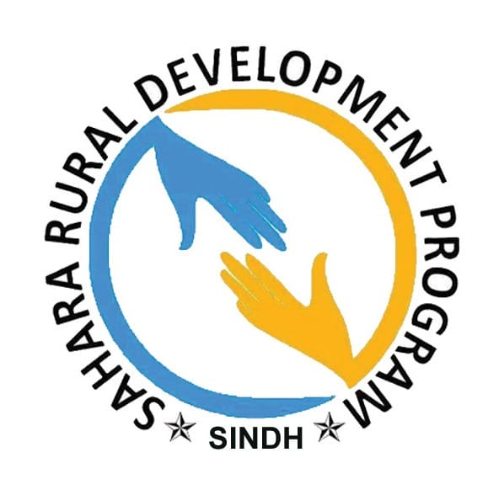

TABLE OF CONTENTS
Sr. # |  | Content | Page #
1. | Background |  | 3
2. | About SRDP |  | 4
3. | Mission |  | 4
4. | Objectives |  | 5
5. | Completed Projects |  | 6
6. | Organogram of SRDP |  | 8
7. | Work Areas |  | 9
8. | Human Rights and Women Empowerment |  | 9
9. | Health |  | 9
10. | In emergency Situation |  | 9
11. | Education |  | 9
12. | Wash, Water & Sanitation. |  | 10
13. | Livelihood |  | 10
14. | Gender Based Violence (GBV) |  | 10
15. | Partnership |  | 11
16. | Staff & Future Plan |  | 13
17. | Picture Gallery |  | 14
18. | Registration Certificate |  | 19
20. | Head Office & Contacts |  | 20

Background
SRDP Sindh is a non-Government and Non-profit organization. The organization is working in different spheres of life like Education, Natural Resource Management, Livelihoods, Women Empowerment, and Advocacy for social issues/human rights, food Security and Social Mobilization, Emergency Response etc. The registered office of the organization currently situated in the city of Hydrabad.
SRDP Sindh geographical area for intervention with communities is the entire province of Sindh with focus on rural areas. It’s important areas of interventions District Shikarpur, Kashmore @ Kandhkot, Qamabr @ Shahdadko Jacobabad, Larkana Dadu, Tando Allah Yar,Mirpur Khas Umerkot & Nausher Feroz.
SRDP Sindh is a growing organization and has been passing through the phase of consolidation, organizational development
SRDP Sindh has experienced and qualified human resources in its head office. Capacity building of staff is a continuous process. The organization believes that Human Development is the key for sustainable development.
Proper implementation of activities according to the work plan is the responsibility of the concerned manager. However, the head office regularly monitors activities of these programs through progress review meetings, field visits and progress reports. Other activities of head office are liaison with the partner organizations.
All the organizational matters are guided by the policy manual which is under development for further improvements with the help of consultations of professional organizations, board members and individual consultants. Regular audit of accounts is conducted by renowned external auditors.
At the time of its formation founder members have a motive to exhibit and expose their endowed abilities along with the candid spirit of Social work. In order to achieve the goal; the organization started to proceed over the path of progress firstly by utilizing endowed abilities and started performing stage programs for a cause of social development. Although at the time of the organization's infancy there were few members yet it increased gradually by inducting suitable members, through interviews.

About SRDP.
SAHARA Rural Development Program - SRDP founded in 2015 and Registered in 2016 under society Act 1860 withheld registration number is 1208/PAR/LRK/2016/01227.
- Vision
SAHARA Rural Development Program Sindh– SRDP is committed to establishing a caring, sharing and loving society, where all human being can access to resource and live with dignity, non- discrimination and effective participation, The Established & Developed Nation with equity would be Core Vision of SRDP Sindh.
- Mission
SRDP Sindh Mission to provide support & Relief to deprived, through goods, services & Advocacy at national to community level, SRDP Sindh only works for the betterment of deprived in various manners, as SRDP Sindh providing relief & support to thousands deprived; SRDP Sindh will provide relief and support without any discrimination, gender, color, race and religion, SRDP’s Relief & Support to all deprived equally and also strive to eliminate hunger, poverty, disease and injustice and make equity.
- Objectives
The objectives of life society are to promote self-help, mutual aid and better living to achieve these objectives,
- To assist and point our human rights violation in any stage.
- To establish educational / vocational institutes and training centers.
- To provide training and guidelines to women for playing the leading role in development society.
- To establish libraries and study circles.
- To motivate the peoples for self-employment and provide the initial resources.
- To motivate the peoples for self-employment and provide self-employment initial resources.
- To provide basic health (technical and general) education, development and employment facilities in the rural areas.
- Emergency Rielf.

Completed Projects
Name of Project | Intervention Area | Sector | Donor | Partner | Budget In (PKR)
Celebration of One Week Sports Activates | Qambar @ Shahdadkot | Sports & Youth | Sports & Youth Affairs Government of Sindh | SRDP | 800,000
Skill Development  Center | District Shikarpur | Vocational Trainings | BBSHRRDB | SRDP | 365,000
Flood Relief Effort | District Kashmore UC Zorgarh | Shelters & NIFs  Emergency &  Winterization  Kits | DFID & IOM | SRDP | -
Flood Relief Effort | District Kashmore UC Lalao | Shelters & NIFs  Emergency &  Winterization  Kits | USAID & IOM | SRDP | -
Flood Relief Effort | District Shikarpur UC Waryaso | Shelters & NIFs  Emergency &  Winterization  Kits | USAID & IOM | SRDP | -
Flood Relief Efforts | District Shikarpur UC Dakhan | Shelters & NIFs  Emergency &  Winterization  Kit | DFID & IOM | SRDP | -
Flood Rielf Efforts | District Qambar @ Shahdadkot UC Muradi | Shelters & NIFs  Emergency &  Winterization  Kit | DFID & IOM | SRDP | -
Flood Rielf Efforts | District Qambar @ Shahdadkot UC Monder Lakha | Shelters & NIFs  Emergency &  Winterization  Kit | DFID & IOM | SRDP | -
Flood Relief Efforts | District Larkana UC Waris Dino Machi | Shelters & NIFs  Emergency &  Winterization  Kit | DFID & IOM | SRDP | -
Flood Relief Efforts | District Naushero Feroz UC Abraan | Shelters & NIFs  Emergency &  Winterization  Kit | DFID & IOM | SRDP | -
Flood Relief Effort | District Shikarpur UC Jahan Wah | Shelters & NIFs  Winterization  Kits | DFID & IOM | SRDP | -
Flood Relief Effort | District Shikarpur UC Ali Bahar | Shelter & NFIs Winterization Kits | DFID & IOM | SRDP | -
Flood Relief Effort | District Shikarpur  UC Jahan Wah | Emergency Shelter Kit ,Shelter Repairing Tool Kit,Diginty Kit,Kichten Set ,Hygiene Kit & NFI Kit Distribution | USAID,JAPAN & IOM | SRDP
Flood Relief Effort | District Dadu Taluka K.N Shah UC Bhugia | Emergency Shelter Repairing Tool Kit Distribution | USAID,JAPAN & IOM | SRDP
Gender Based Violence | District Shikarpur | Sexual Harassments | SPO |  | 347,000
Establishment of Computer Lab | District Shikarpur UC 8 | Education | DTCE |  | 272,000
Skill Development for All | District Shikarpur | Vocational Trainings | BBSHRRDB |  | 405,000
Skill Development for All | District Shikarpur | Vocational Trainings | BBSHRRDB |  | 741,500
Celebration One Week Street Children Cricket Tournament @ Shikarpur District | District Shikarpur | One Week Street Children Cricket Tournament | Sports & Youth Affairs Government of Sindh |  | 700,000
Skill Development for Youths | District Shikarpur | Vocational Trainings | BBSHRRDB |  | 265,000
Celebration 3three Days Wallay Ball Tournament @ Kashmore @ Kandhkot | District Kashmore @ Kandhkot | Celebration 03three Days Wally Ball Tournament | Sports & Youth Affairs Government of Sindh |  | 800,000
 |  |  | Grand Total Grant |  | 4,69,5000

Two Approved Project in Monsoon Humanitarian Operation Plan 2022

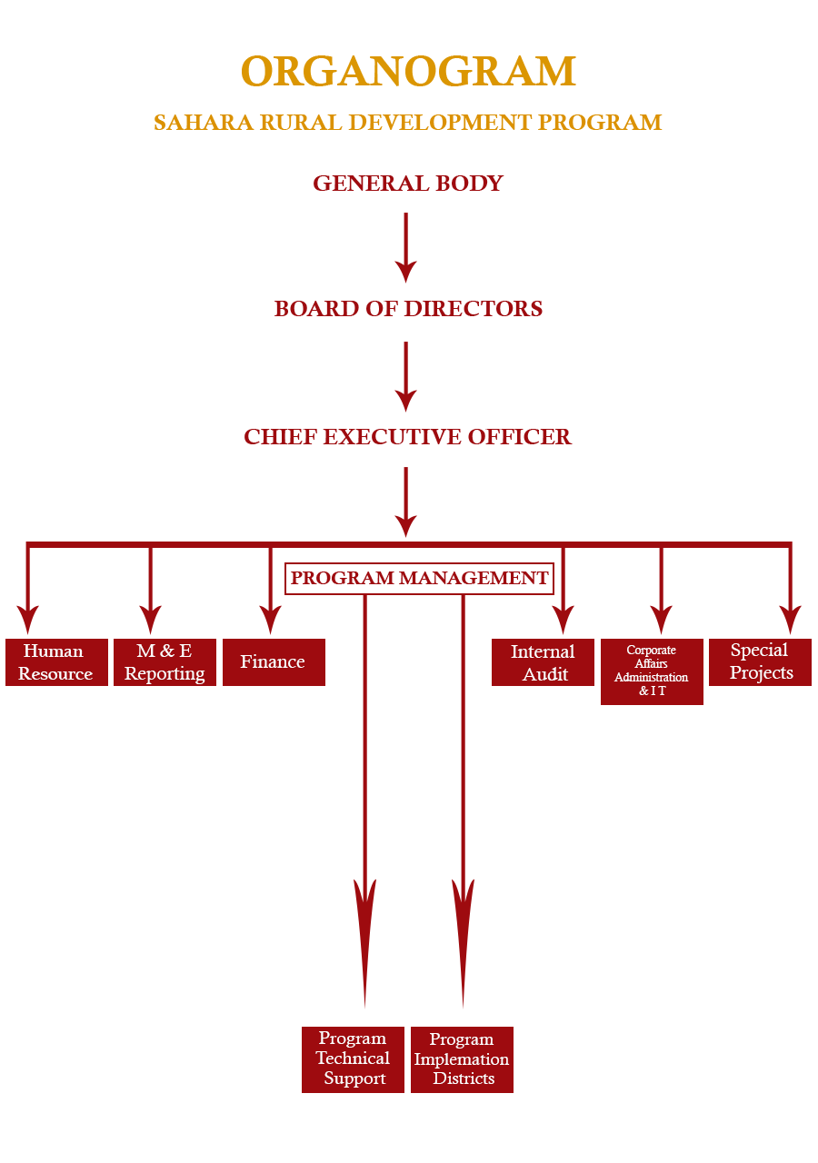
Organ gram of SRDP

Work areas
- Human Rights and Women Empowerment:
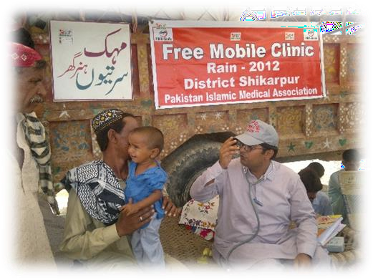
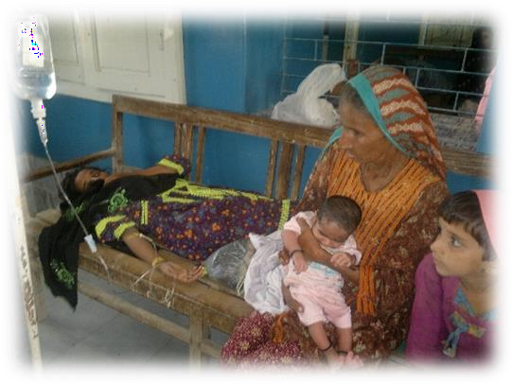
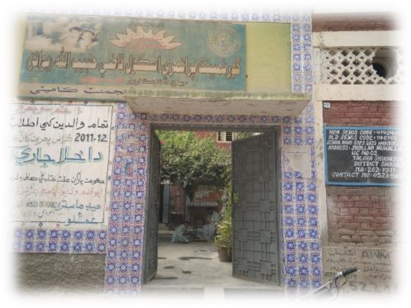
We want to work on women issues because women in our society are very vulnerable. She tolerates violence abuse, carnation because of these issues, women haven’t access to their rights & also we know that women haven’t decision making power because of unawareness. We want to aware & empower women to build a good society. “Women said if you want a good society you or ivied me education & awareness, I’ll give you an educated society”
- Health
Work on primary health care for children & women, we want healthy well aware communities though PHC & give them awareness about health & hygiene water-borne diseases.
- In emergency Situation:
After the disaster our community’s health condition is very worse & in the monsoon season every year the same condition again came in our communities & if we work on PHC we can control people’s diseases.
Focus on women pregnant (ante-natal, postnatal care), lactating women, and nutrition & malnourished children under five years.
- Education:
SRDP Sindh Sindh want to open learning centers, Computer centers, Basic education in district/Tehsils and UC wise and specially focus on after flood/disaster those schools which were open & provide education of children and those schools are closed SRDP’s Mission to restore those schools which are provide primary education to the children specially for girls because education is their basic right & SRDP Sindh want to give them their rights.
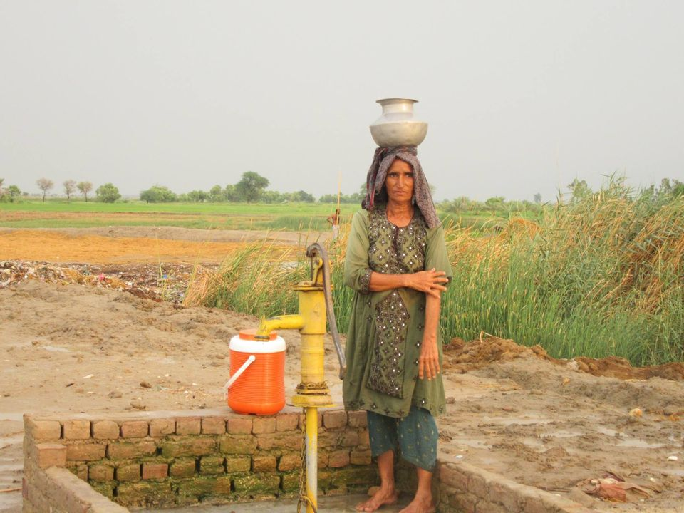
Wash, Water & Sanitation.
SRDP Sindh wants to provide deprived peoples a healthy environment through providing them hand pumps, washrooms & also give them awareness about health & hygiene. And complete education on primary health/hygiene. Because many people live in unhygienic conditions even they don’t have washrooms/latrines in their areas.
- Livelihood:
To provide livelihood opportunities to support their poverty and reduce poverty, Work on livelihood. Livelihood is the part of people's life through that we can measure the social economics conditions of people livelihood is important part of rural people such as livestock, polity, fisheries & agriculture land because of flood people’s livelihood were worst destroyed we want to help them who were totally depended on livelihood we try to help them to improve their life.
- Gender Based Violence (GBV):
It’s hard to admit it, but maybe teachers are on to something with midterm exams. Sure, many sleepless nights, empty coffee cups and gnawed pencils are often needed to pull off a good grade, but the test does serve a purpose. It gives you an idea of where you’re at in the class.
October is just shy of the time when most have midterms, but we challenge you to test yourself anyway. Since its Domestic Violence Awareness Month, it’s the perfect time to check the status of your relationship. For those not in a relationship, look at the criteria below and see if you’ve experienced any of these with a past relationship or maybe even with a friend.

PARTNERSHIP




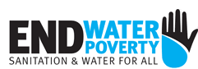
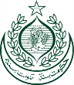
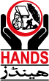
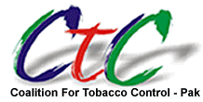
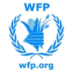
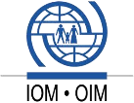
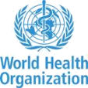
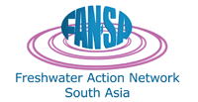
SRDP is growing organization that can approach to build partnership with local and National NGO’s CBO’s, SRDP is enhancing capacity through the partners and partnership as well.

Partners

Donors
--International Organization for Migration - IOM
--DFID, JAPAN, CERF (indirect donors with IOM)
--Devolution Trust for Community Empowerment (DTCE)
--Local Communities
-- Strengthening Participatory Organization-SPO
-- Health and Nutrition Development Society-HANDS
--Benazir Bhutto Youth Development Program-BBSYDP
--Child Rights Movement-CRM
--Sindh Human Rights Commission-SHRC
--AAHUNG
--SHUDDHI
--Hague Education Welfare Trust-HEAT Lahore
-- Islamic aid UK
--Coalition for Tobacco Control-CTC Islamabad
--Special Education Department Government of Sindh
--Civil Society Support Program-CSSP
--National Education Foundation-NEF
--National Commission for Human Development-NCHD
-- Idara-e-Taleem-o-Aagahi-ITA
--SaveTheChildren Pak
--Health Department Government of Sindh
--Education Department Government of Sindh
--Social Welfare Department Government of Sindh
--Benazir Income Support Program-BISP

Staff
11 Female
15 Male
100 Volunteer

Future Plan
Promoting the vision & mission of SRDP Sindh with new opportunities for the civil society in general & the poor masses in particular, there is a need to respect our environment on which our very lives are dependent, to protect our bio diverse cultures & traditions & values.
SRDP is making plans to promote & legacy which is different in nature & also to struggle will have to decrease their poverty & promote the culture values.
Further in future plan SRDP Sindh struggle for women issues such as discriminatory practices against women, domestic violence, and sexual harassment of women by local influential, promotion of human rights & girl’s education; also planning to educate the school children on civil & political rights as guaranteed in constitutions of Pakistan. The objective of this intervention is to make the future generation of the nation of their civil & political rights, peace full, and tolerance, which will have a respect full place on the global scenario and are going to achieve SRDP’s Goal and make vision to reality.
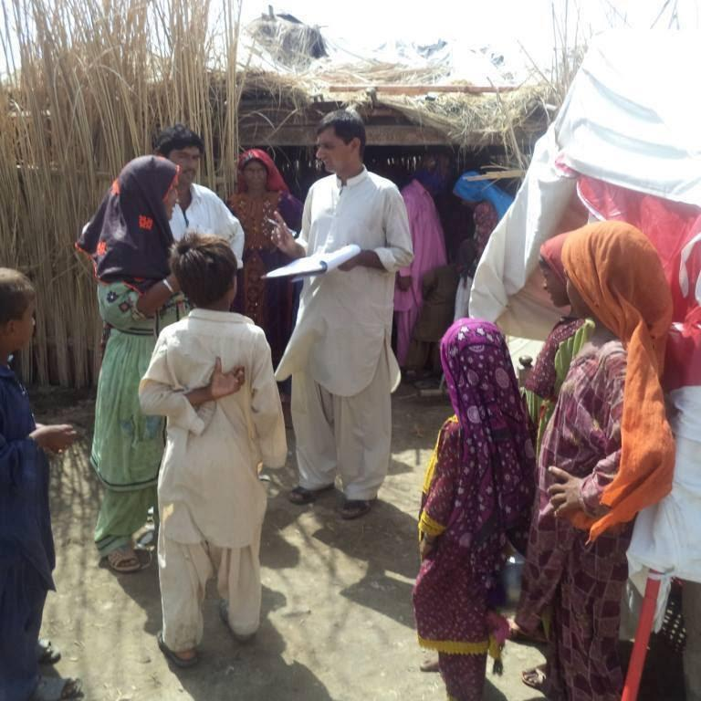
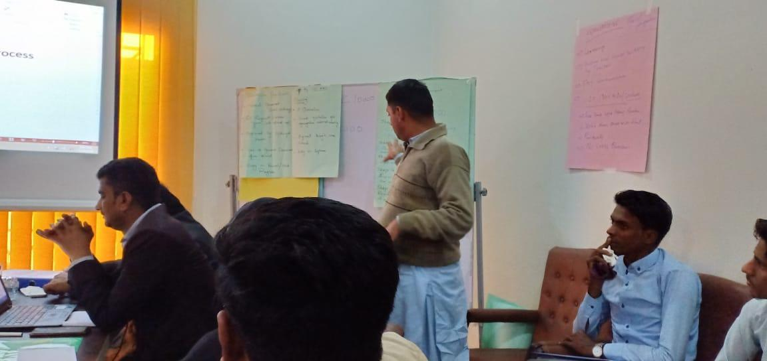
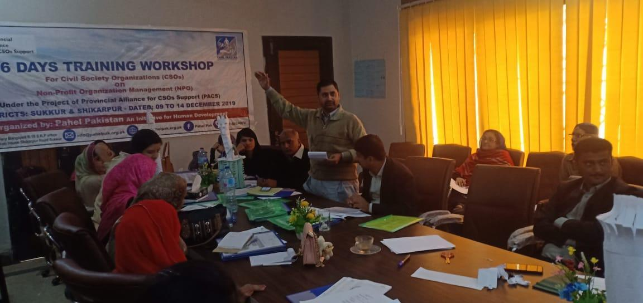
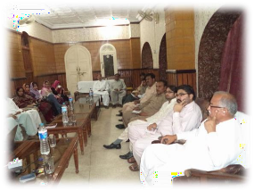
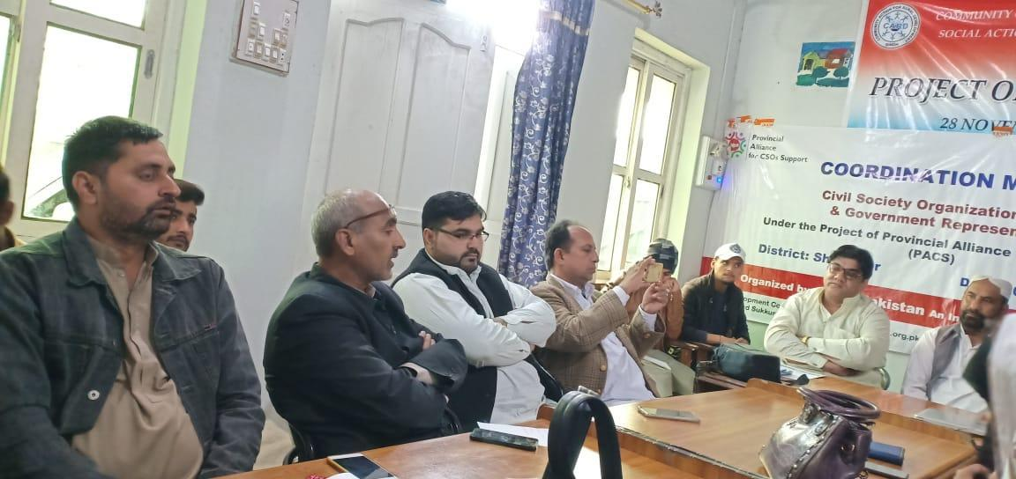
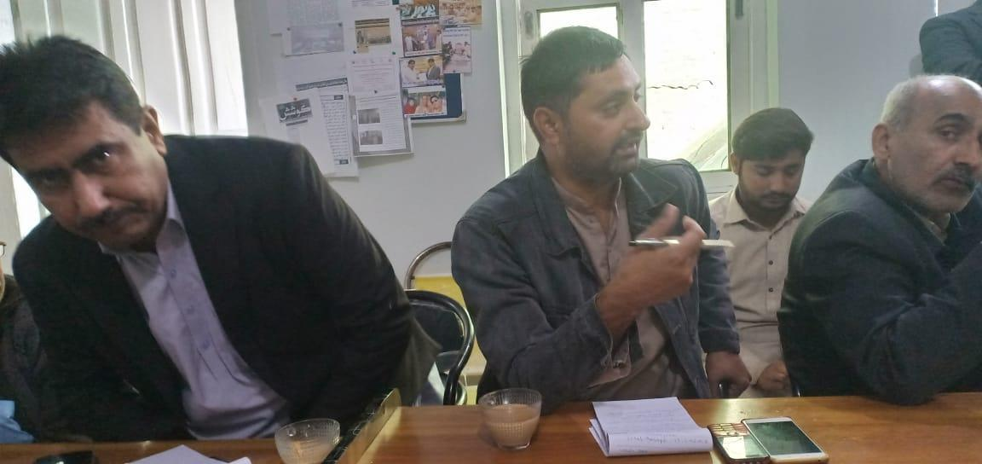
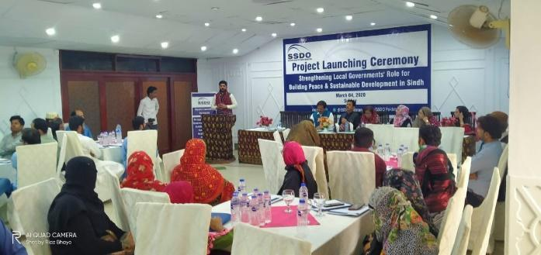
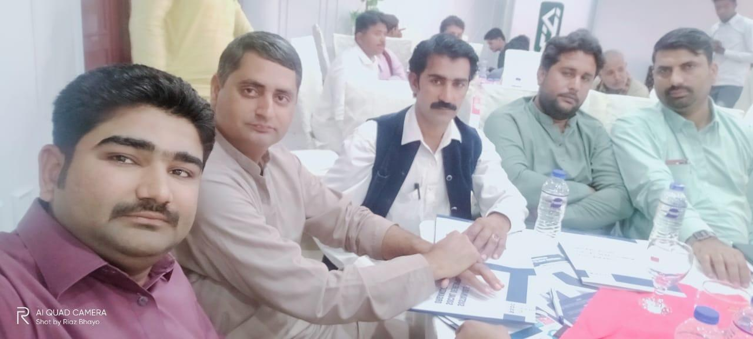
PICTURE GALLERY

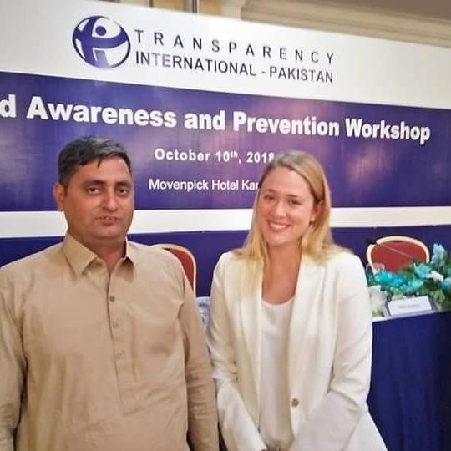
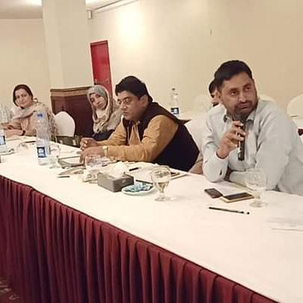

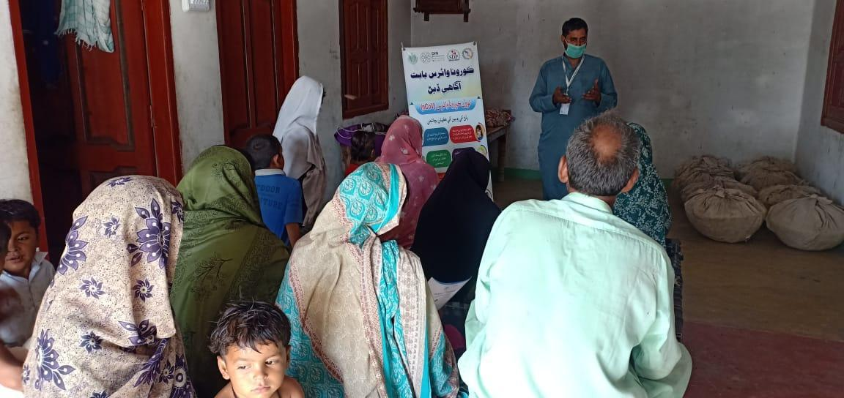
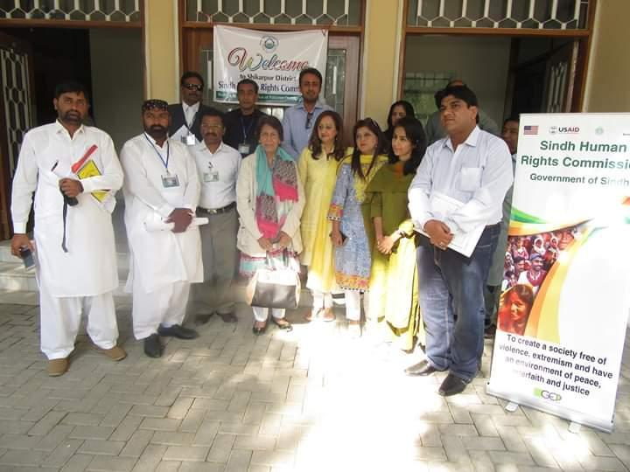
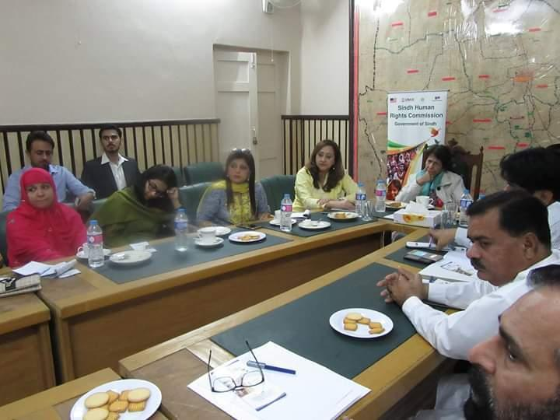
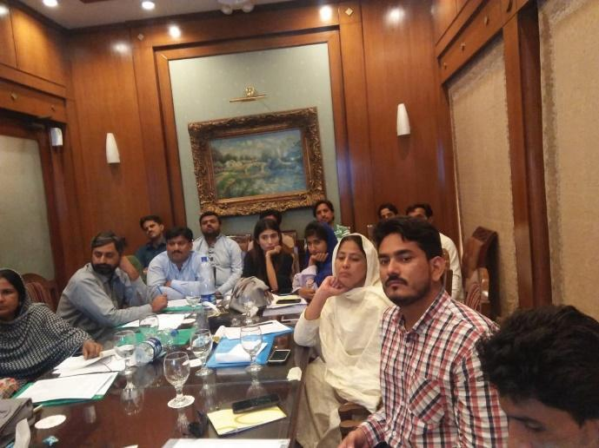
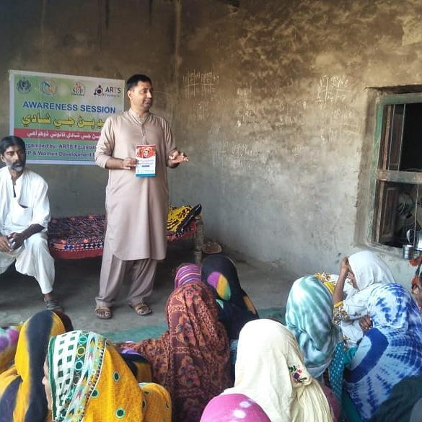
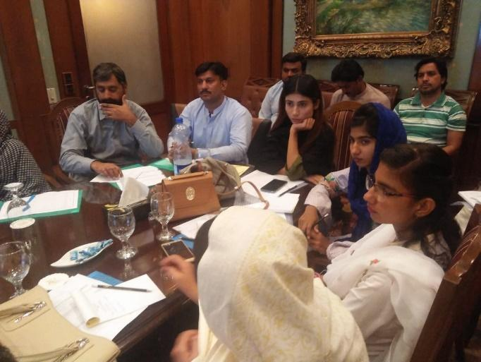
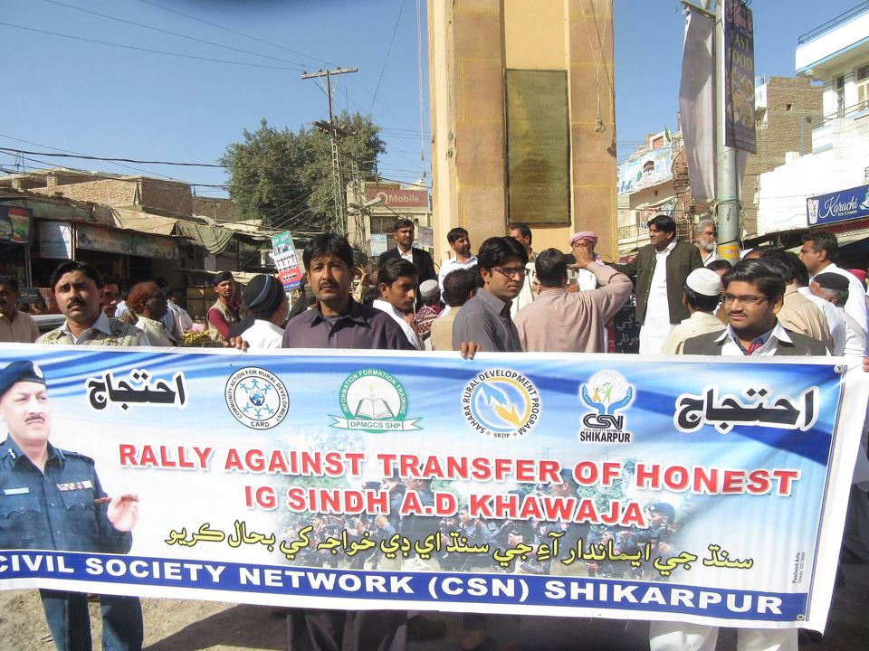
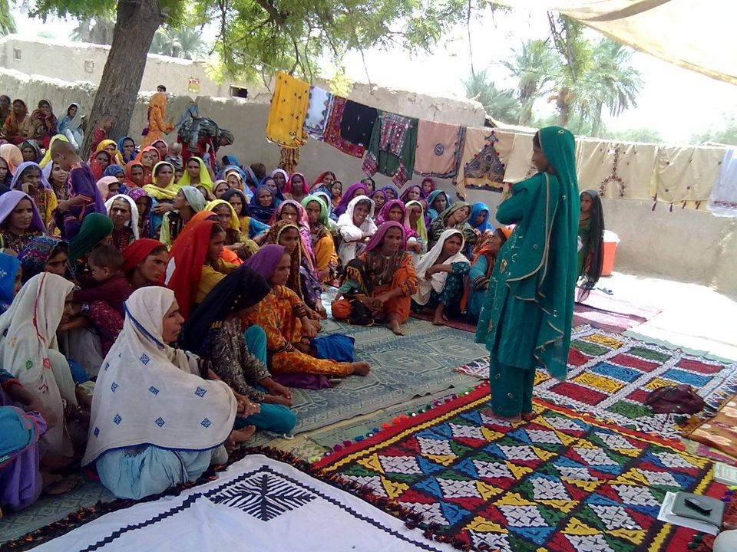
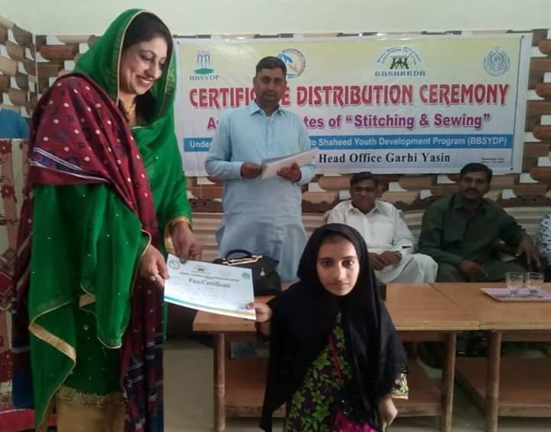
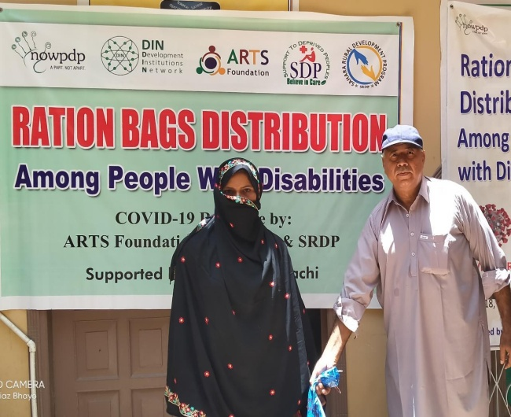
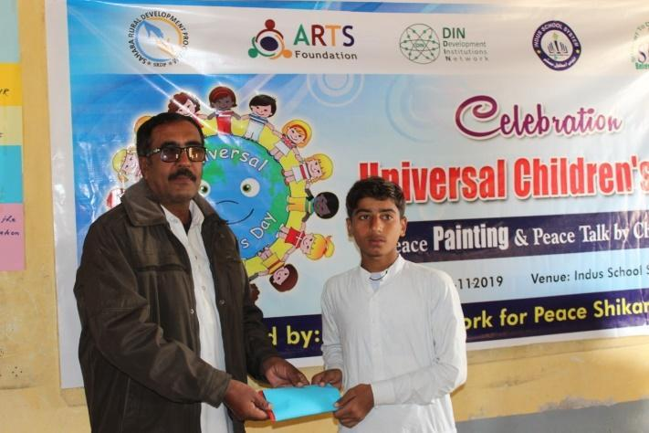
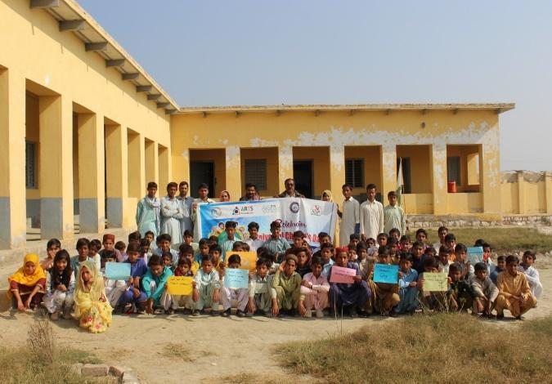
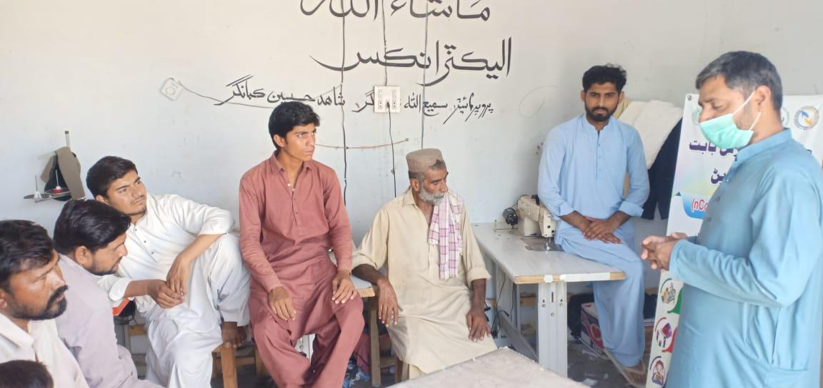
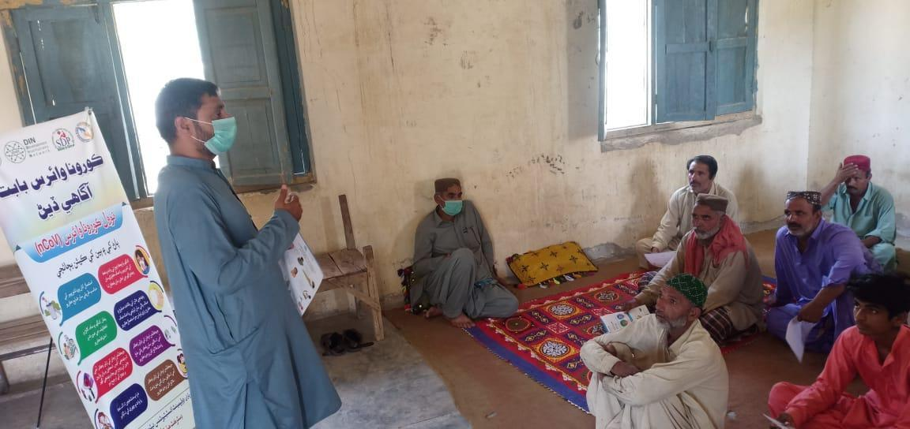

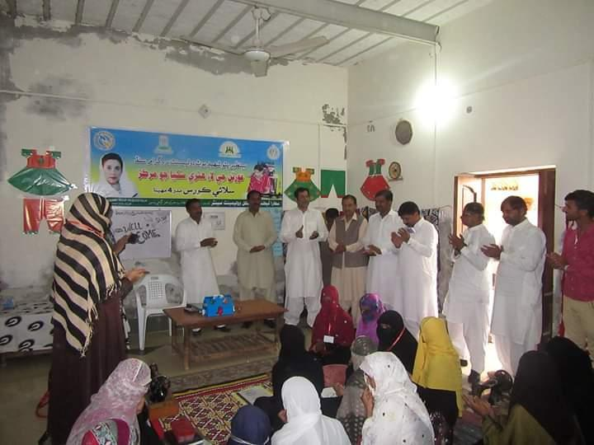
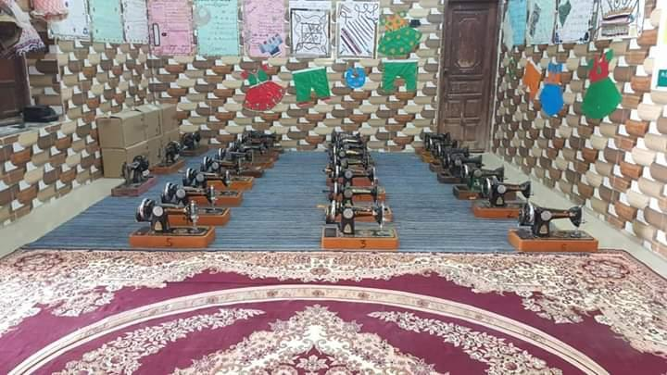
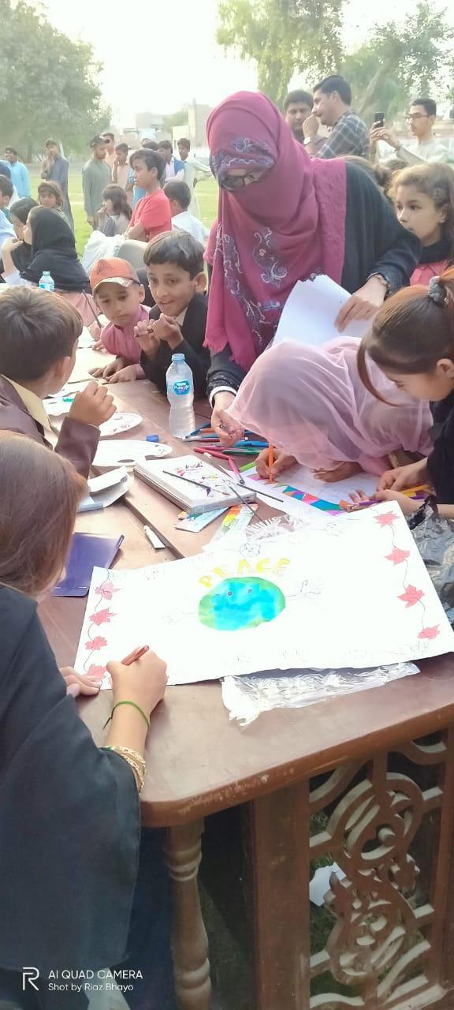
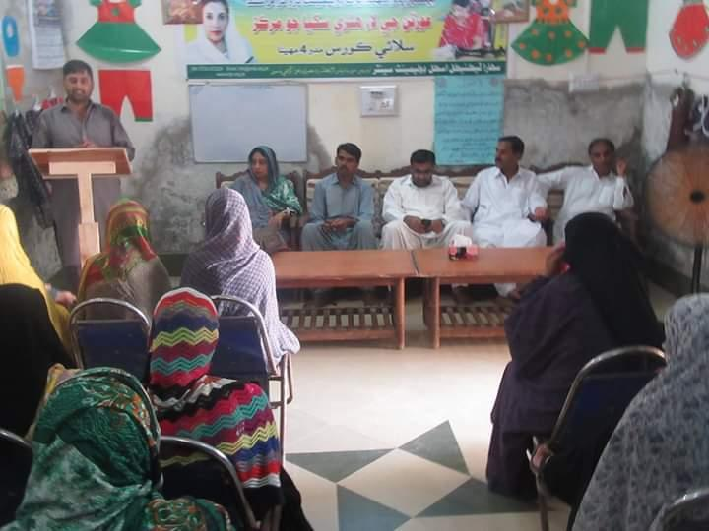
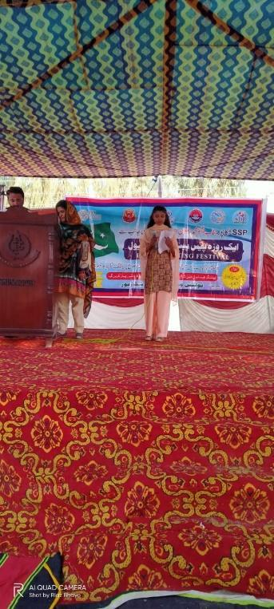
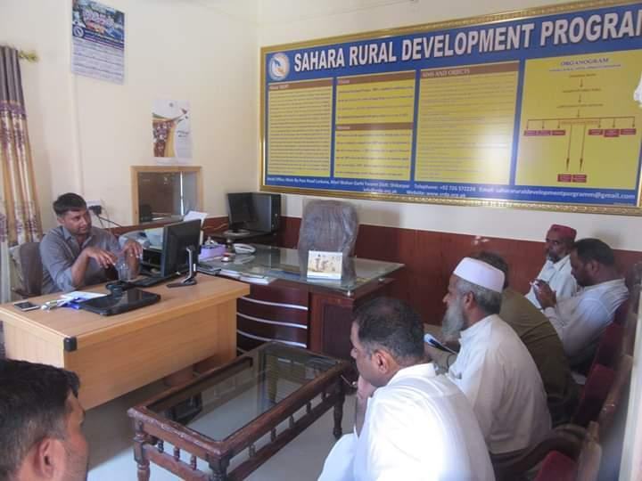

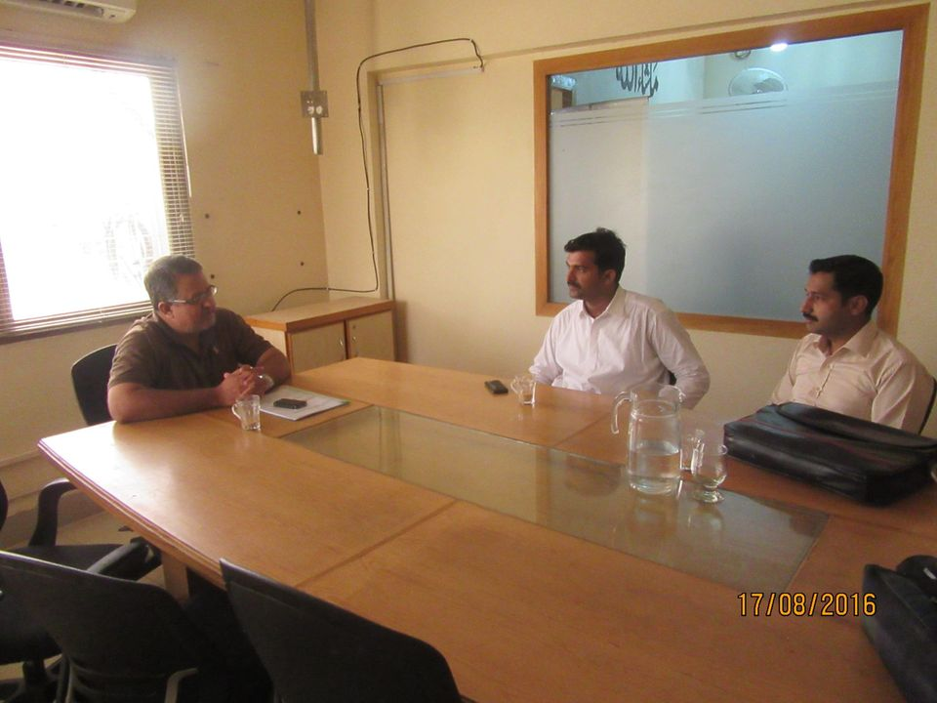
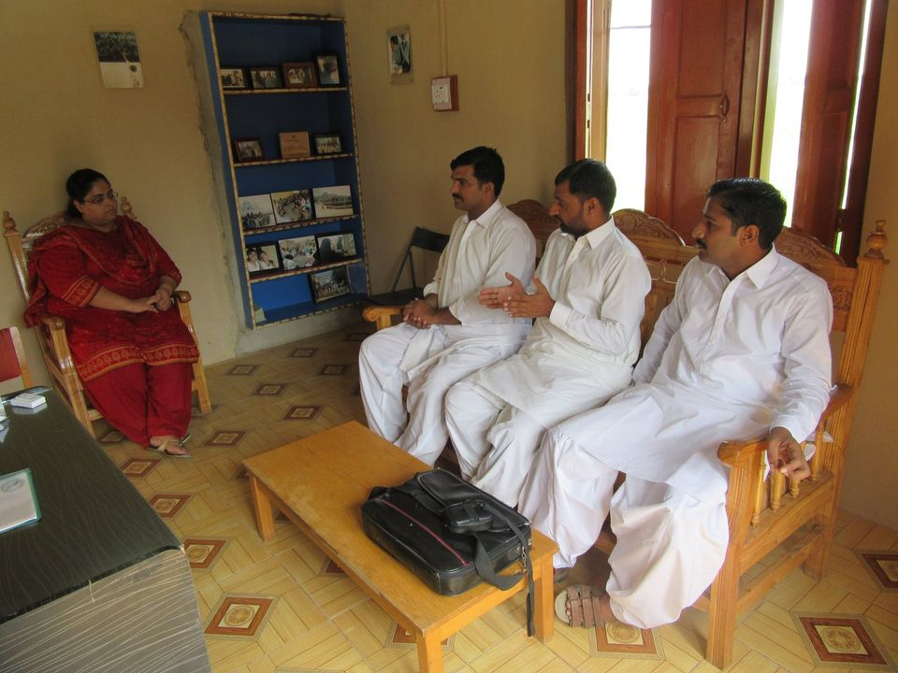

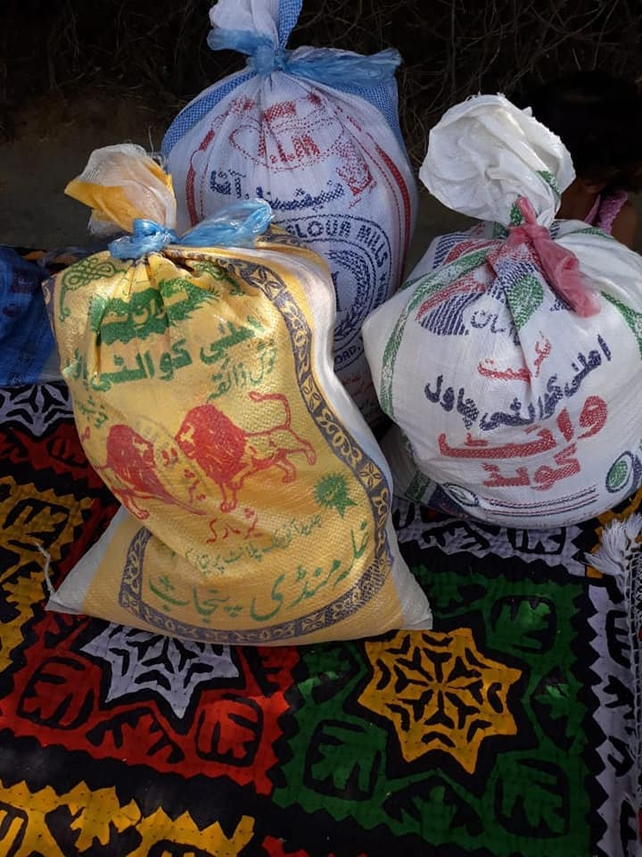
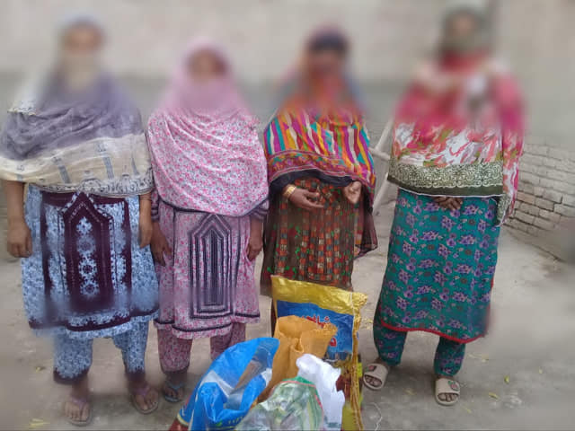
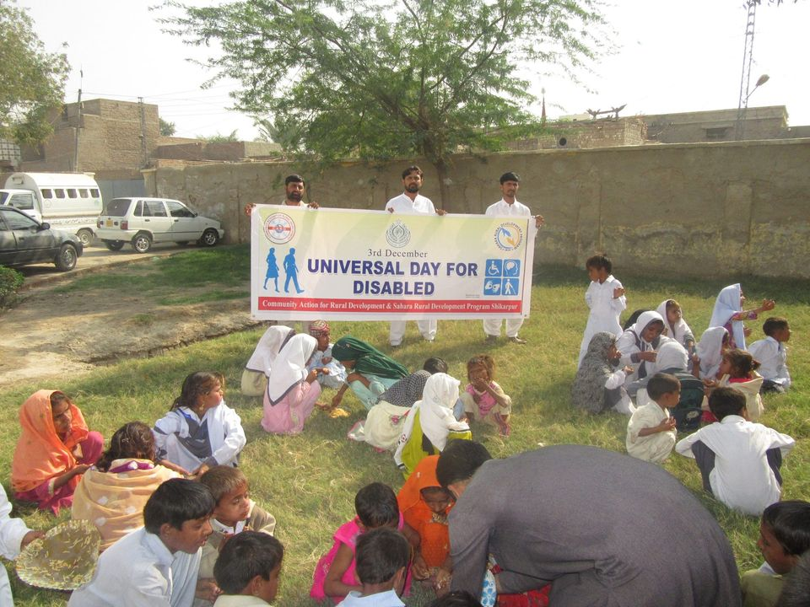
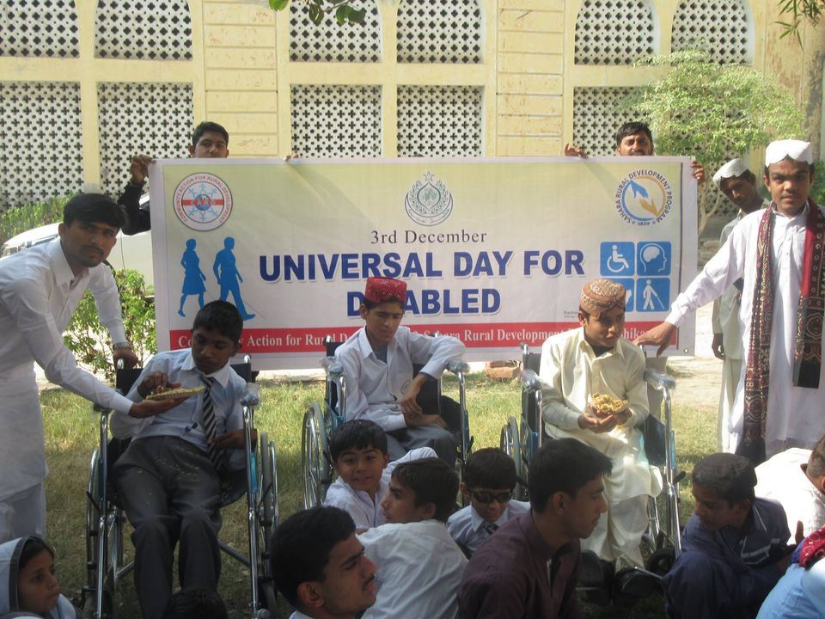
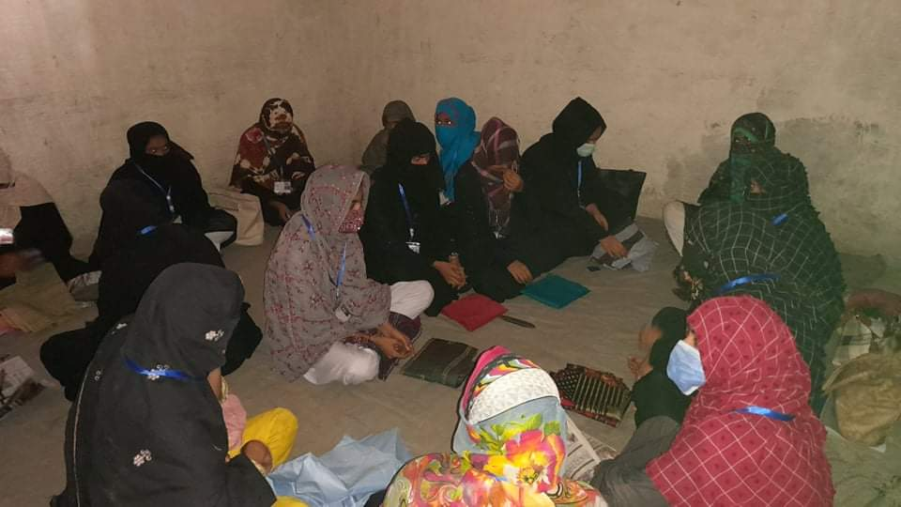
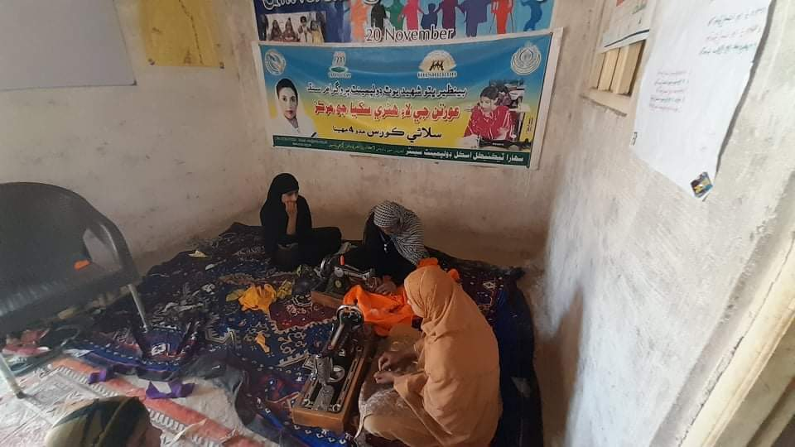
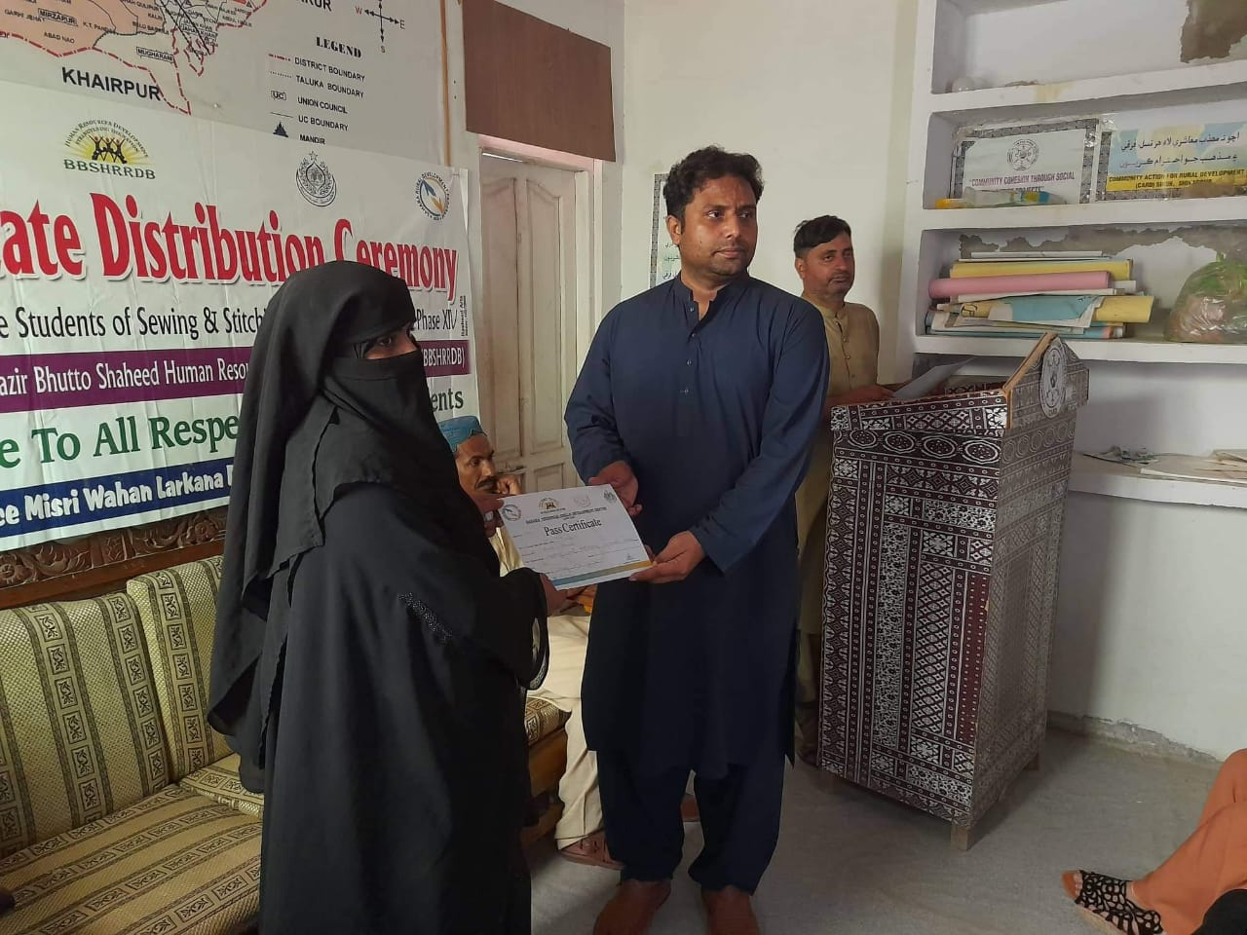

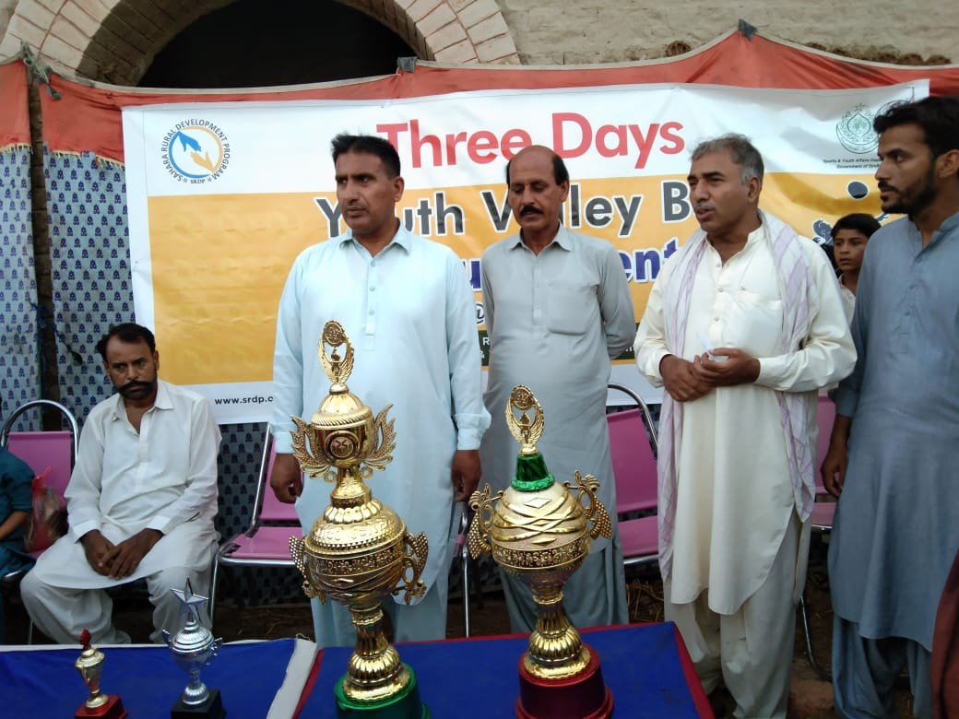
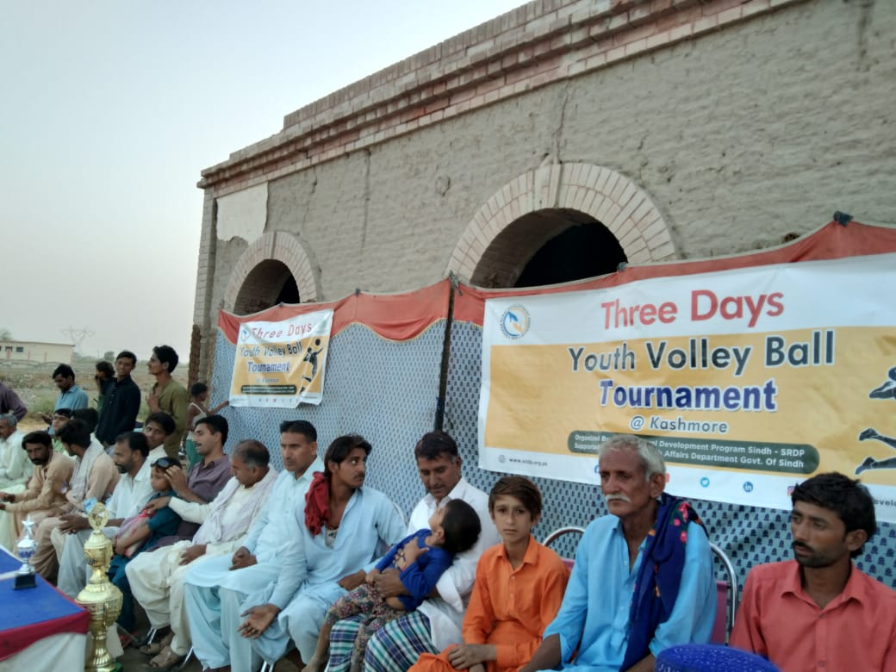
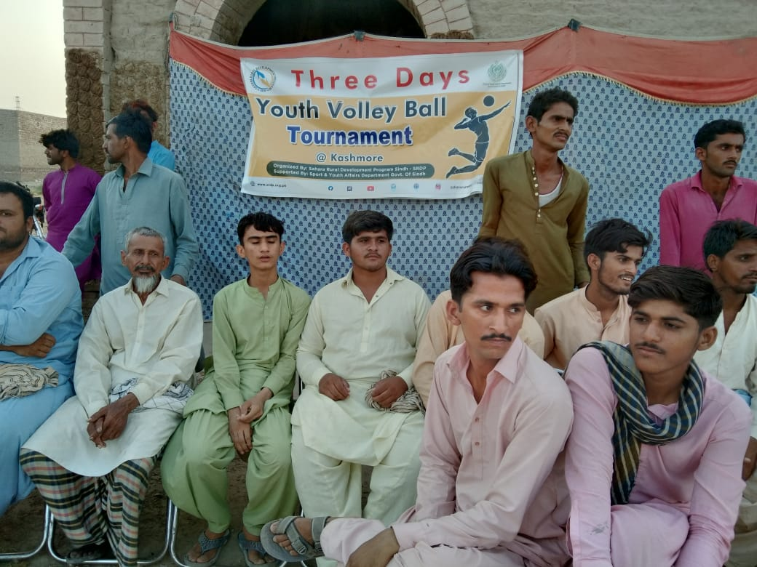

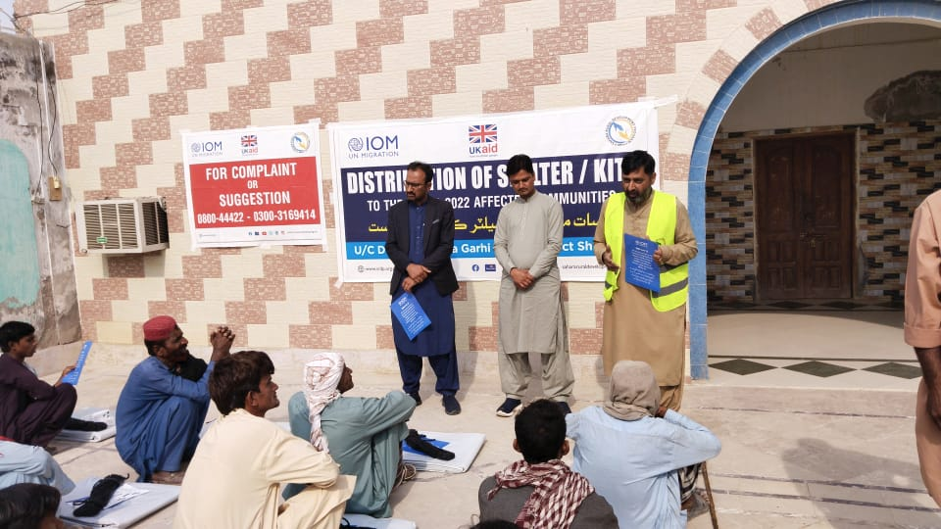
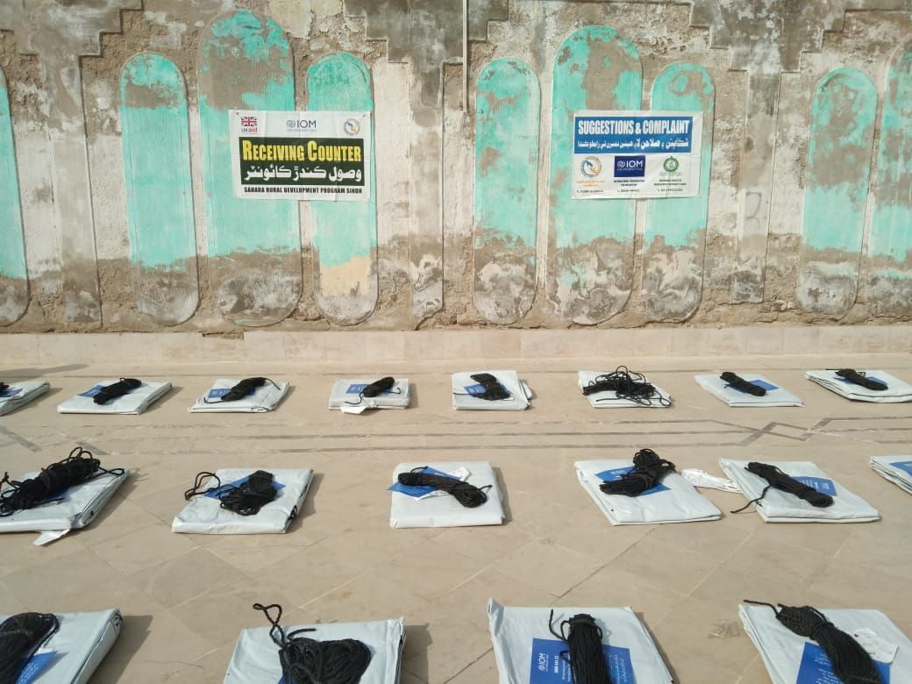
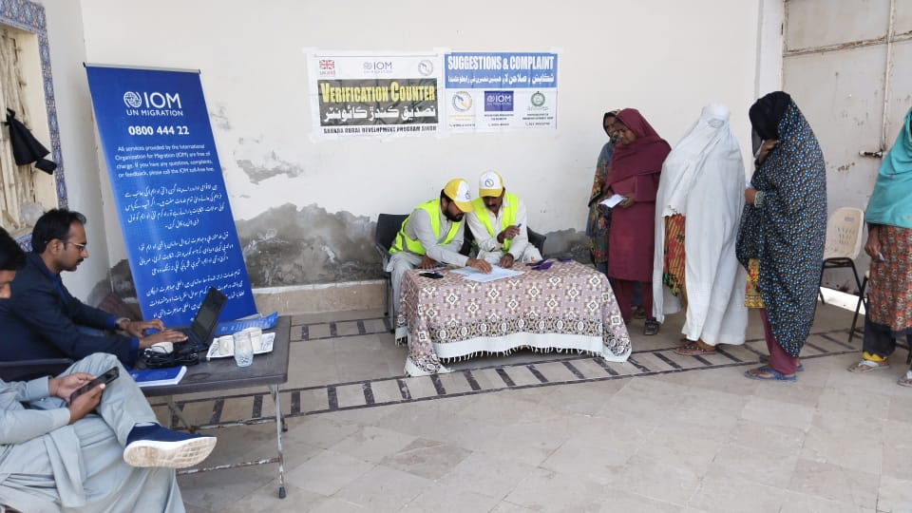
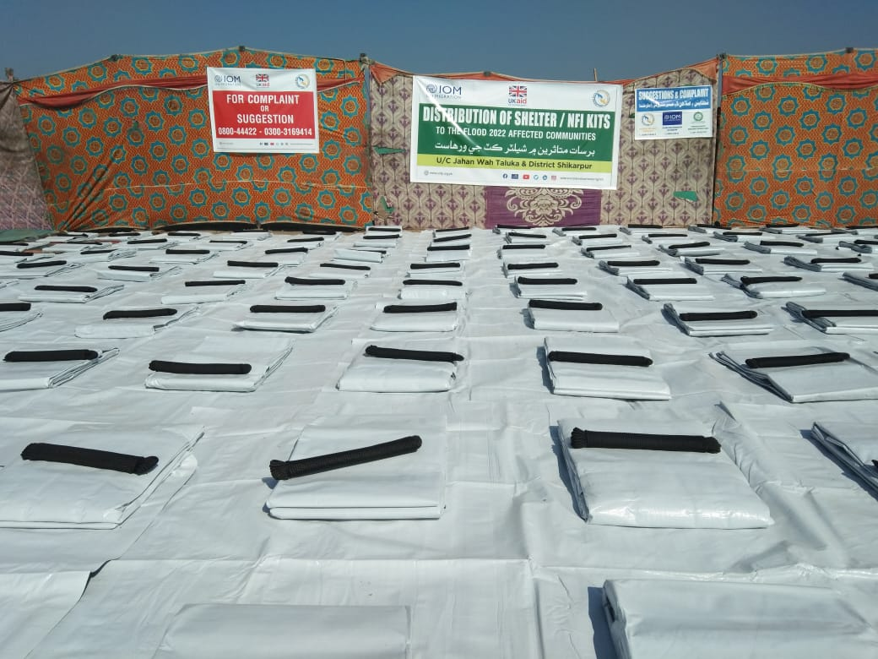
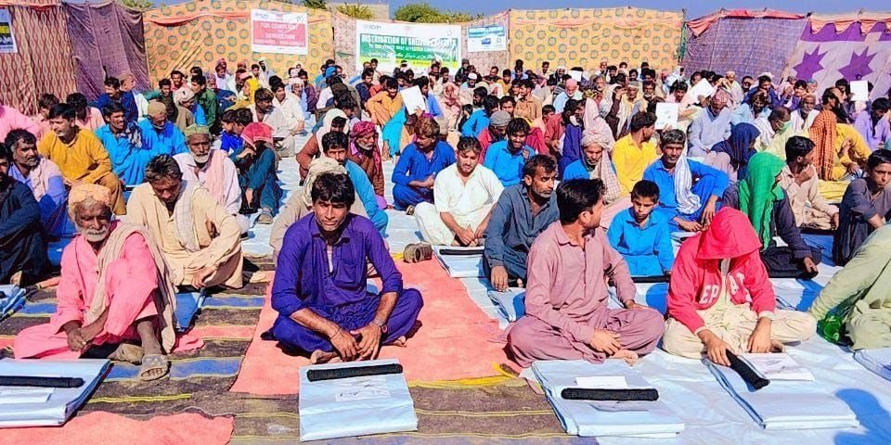
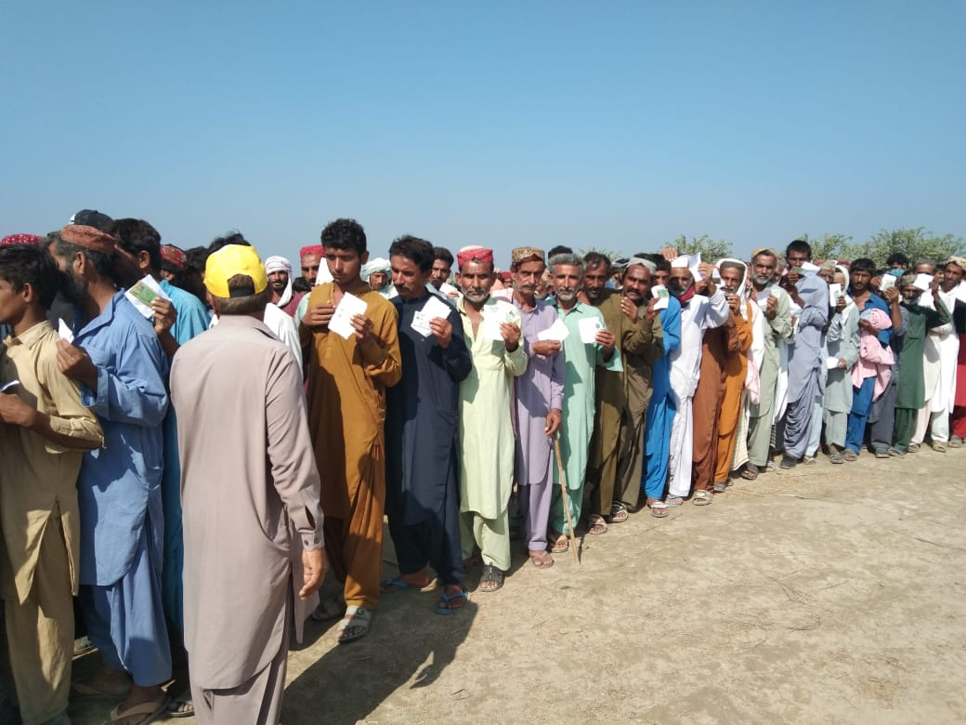
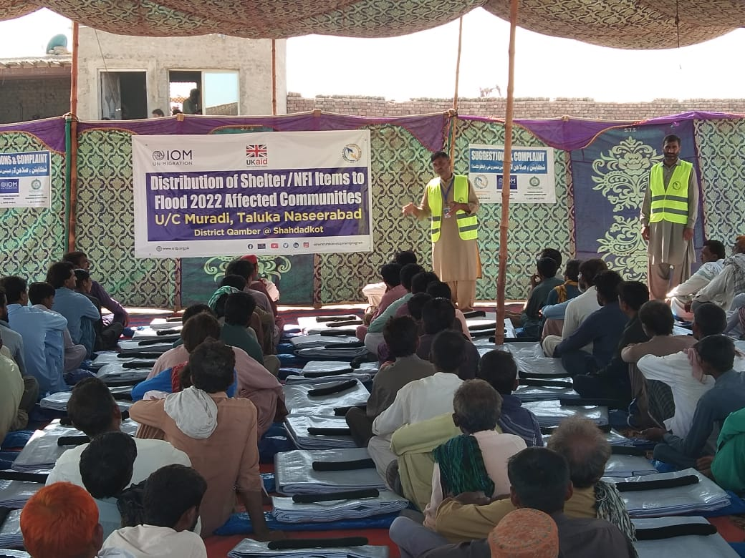
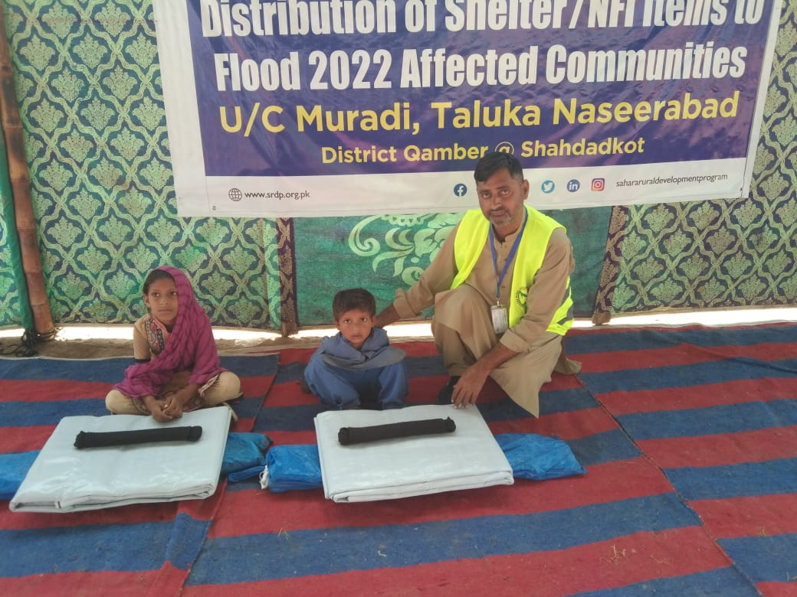
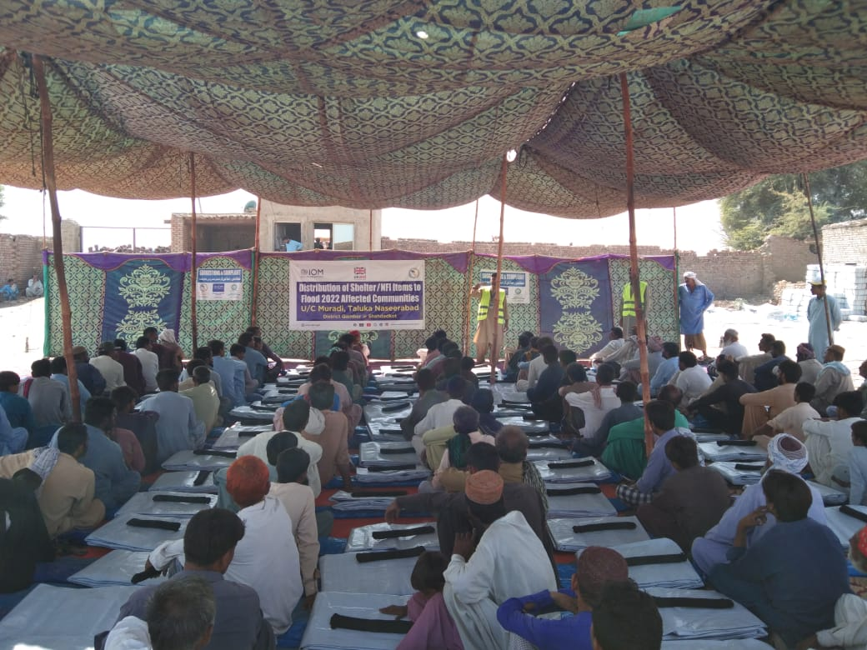
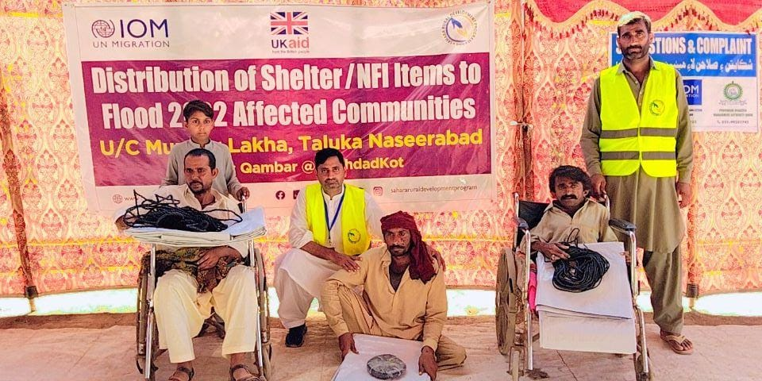
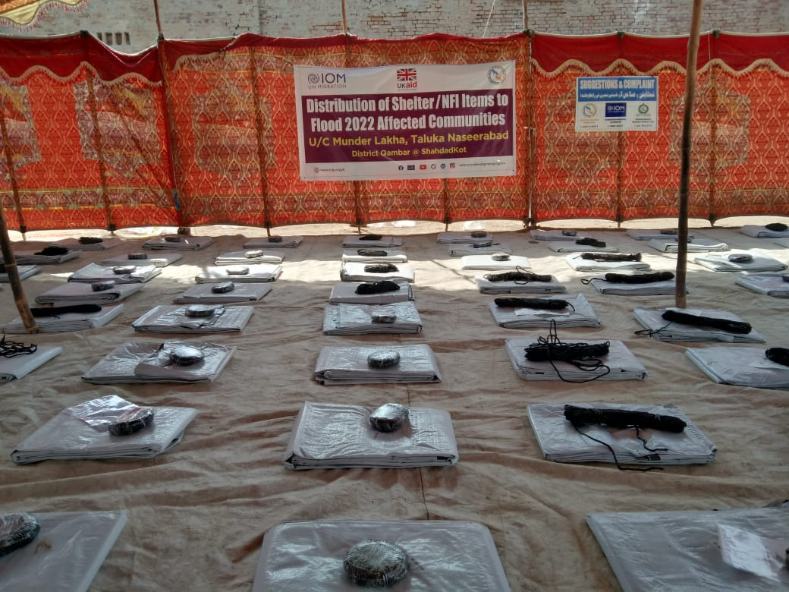
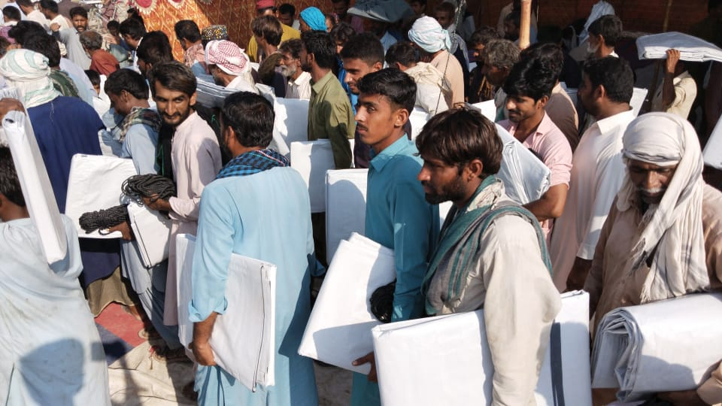
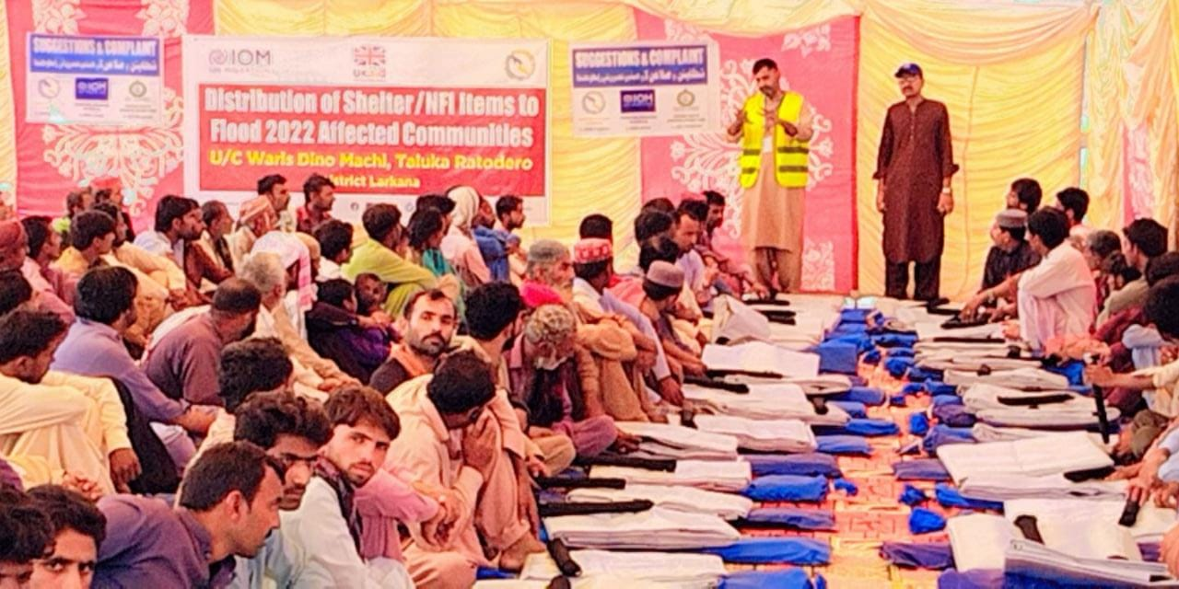
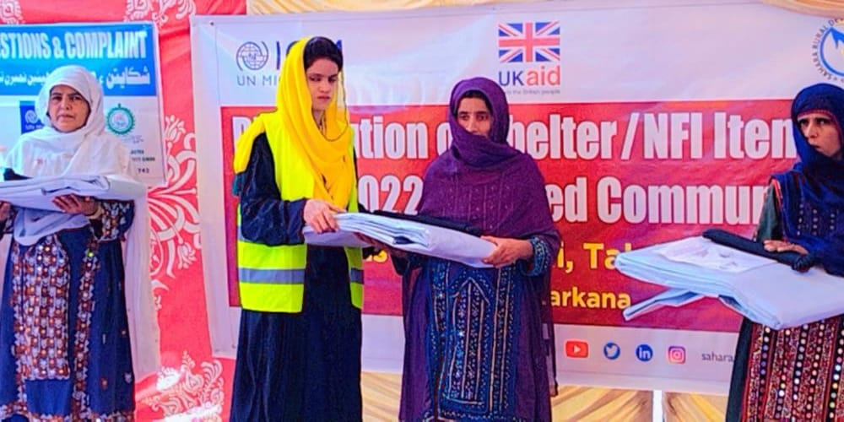
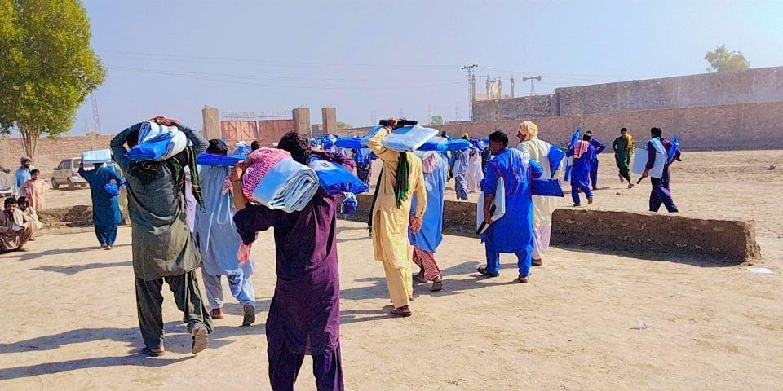
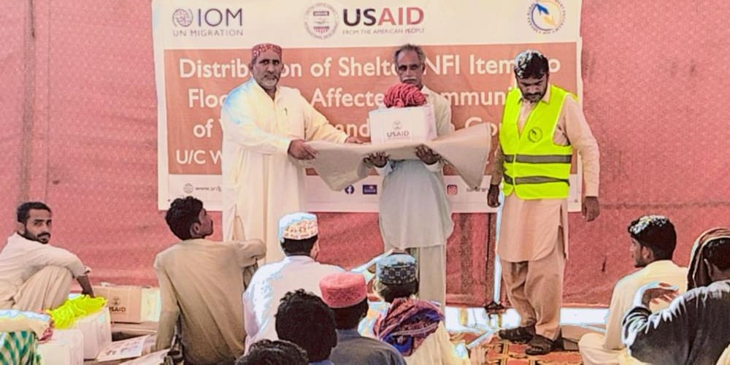
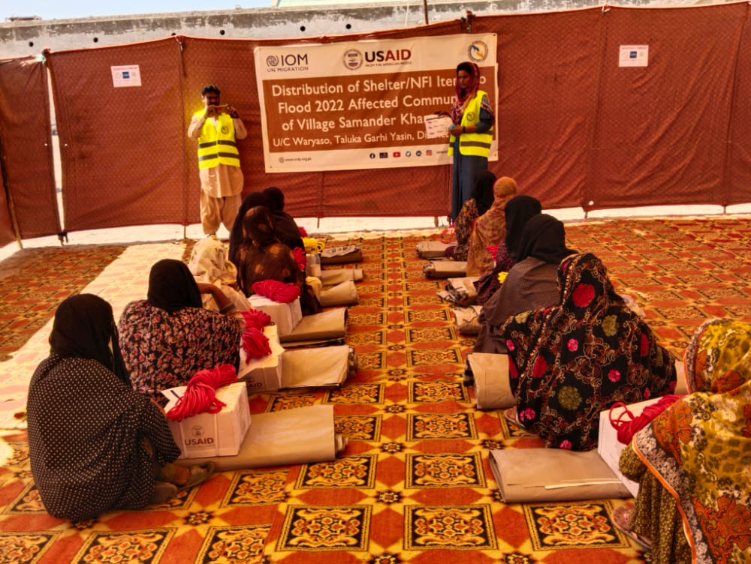
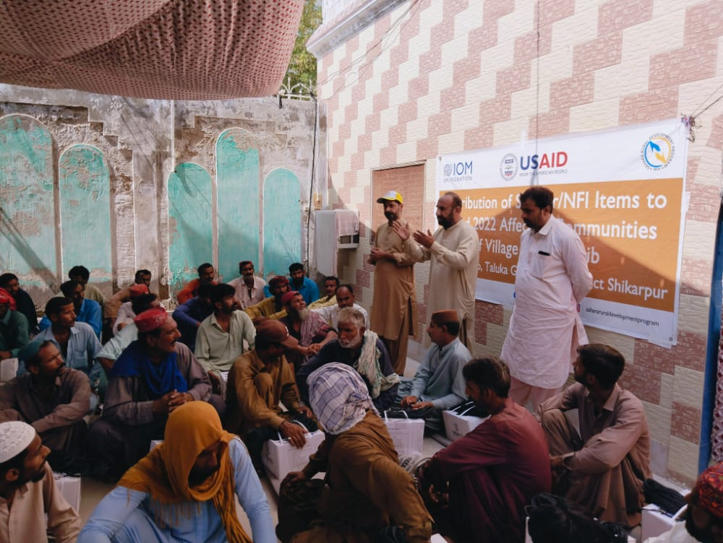
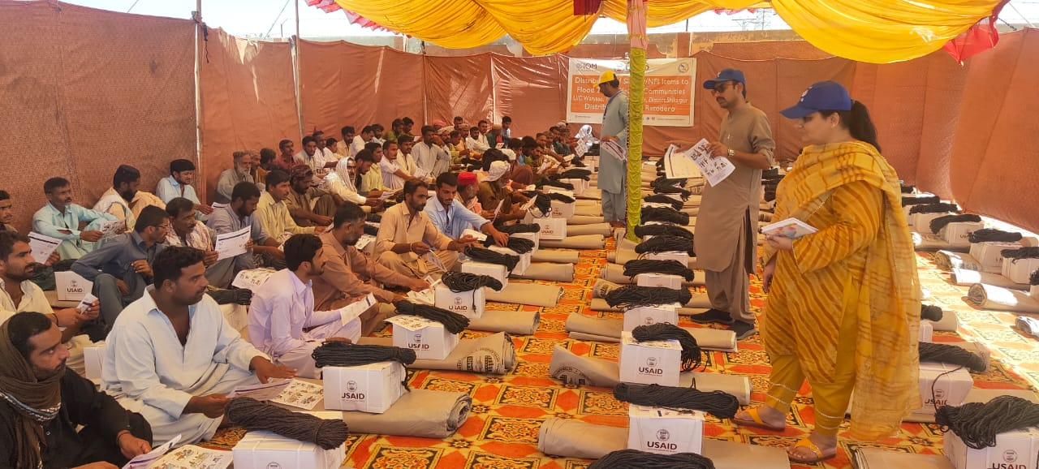
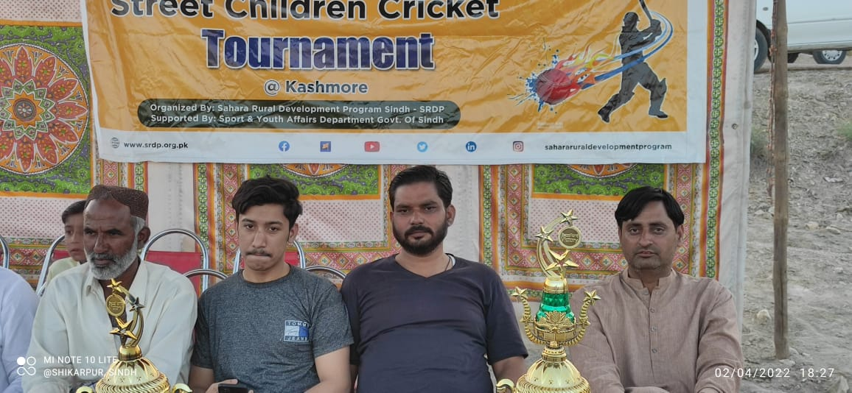
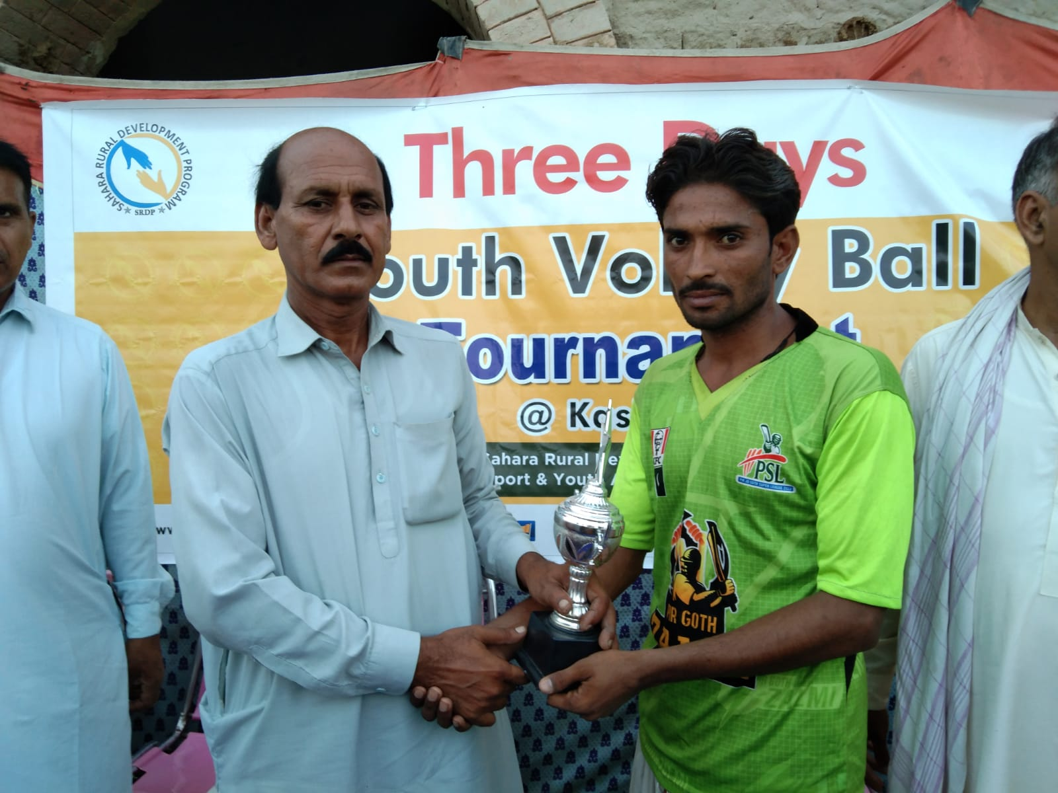
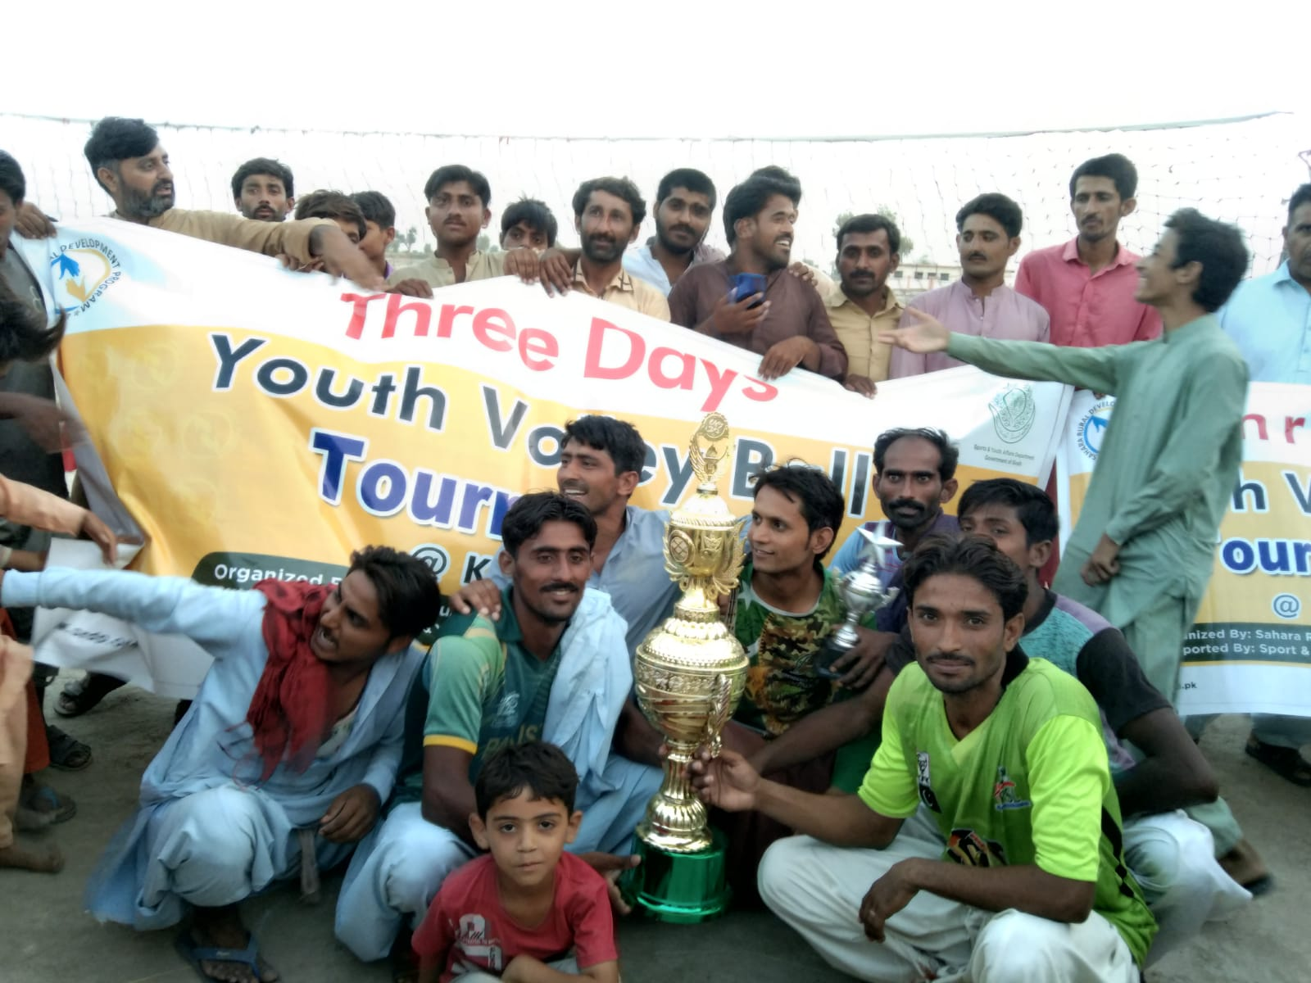
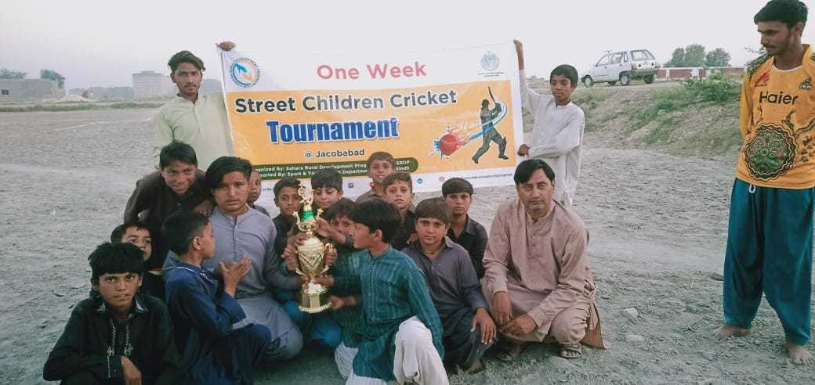
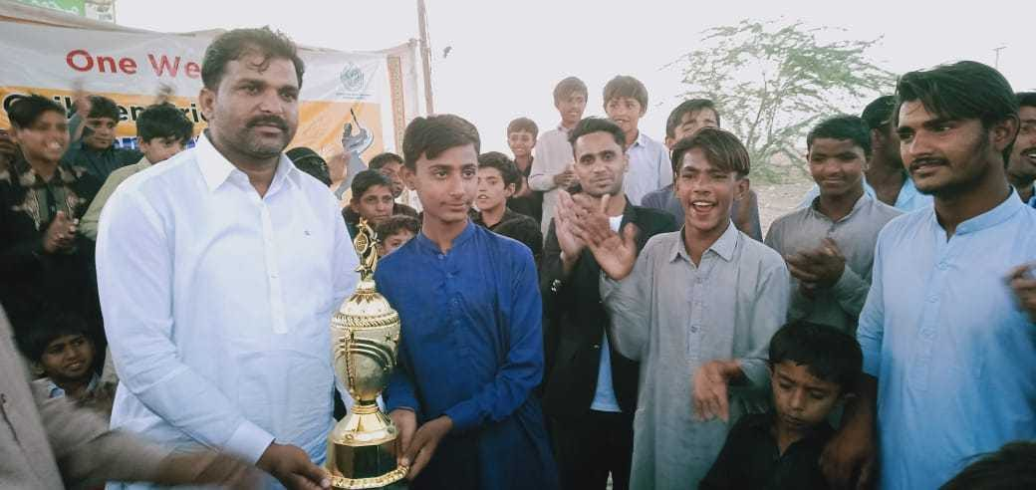
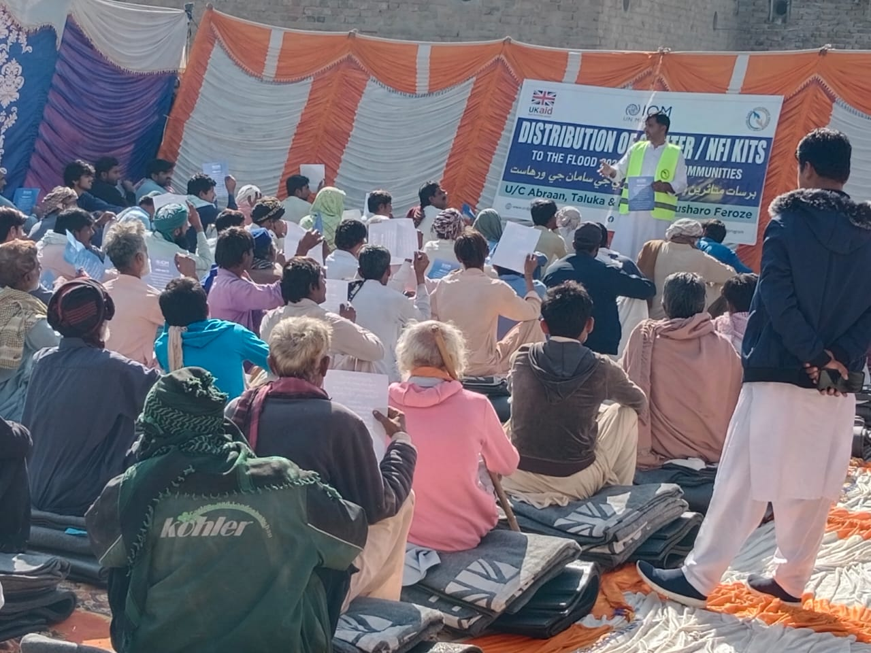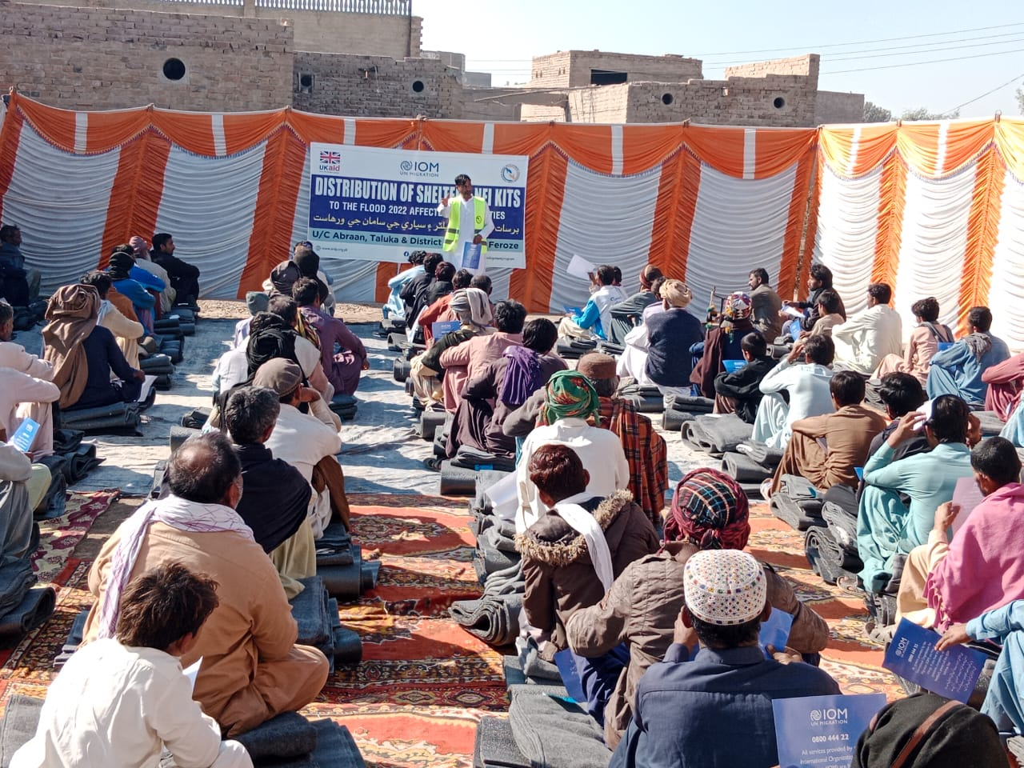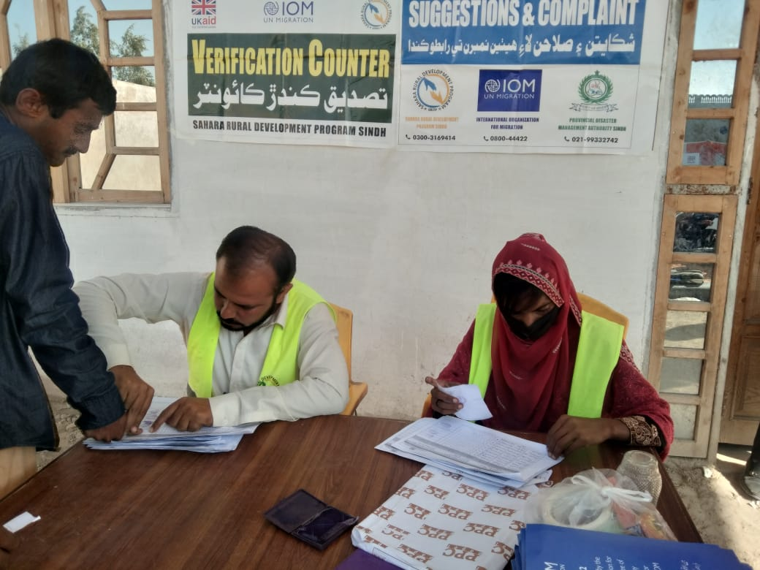
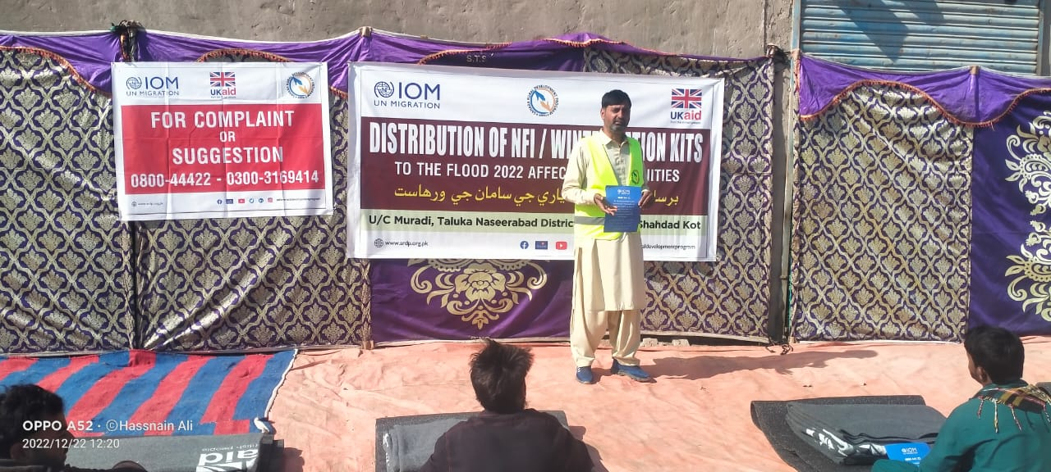
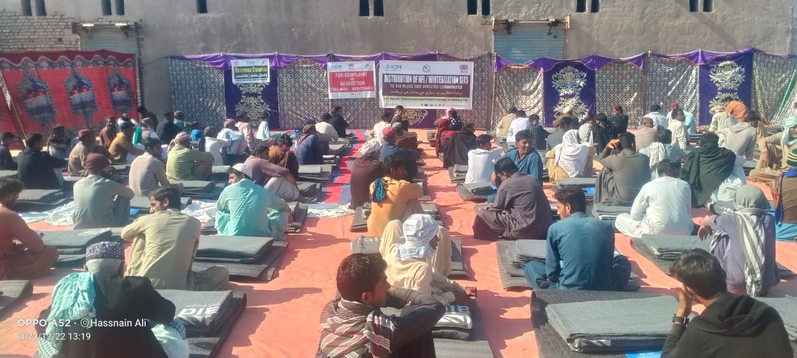
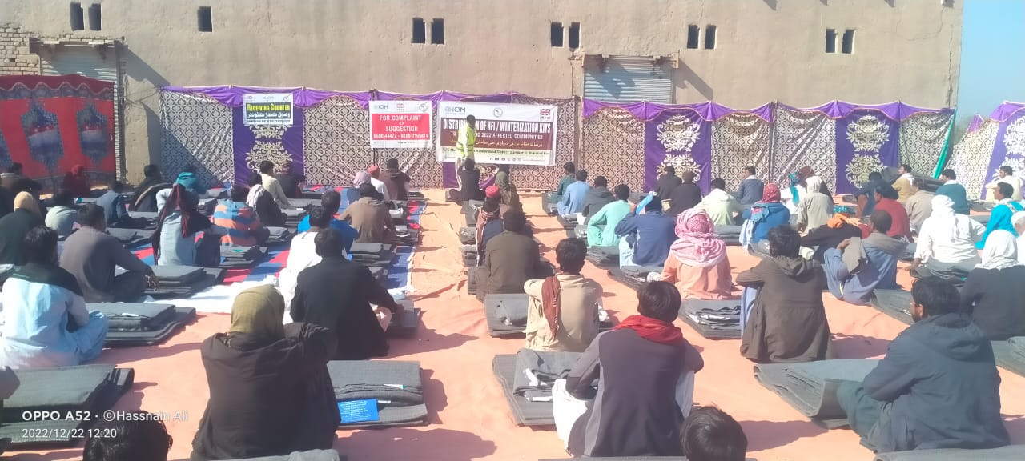

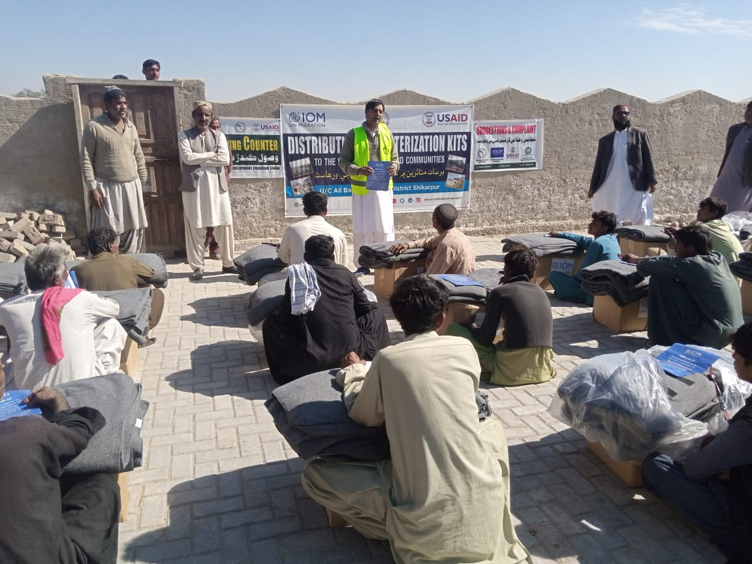
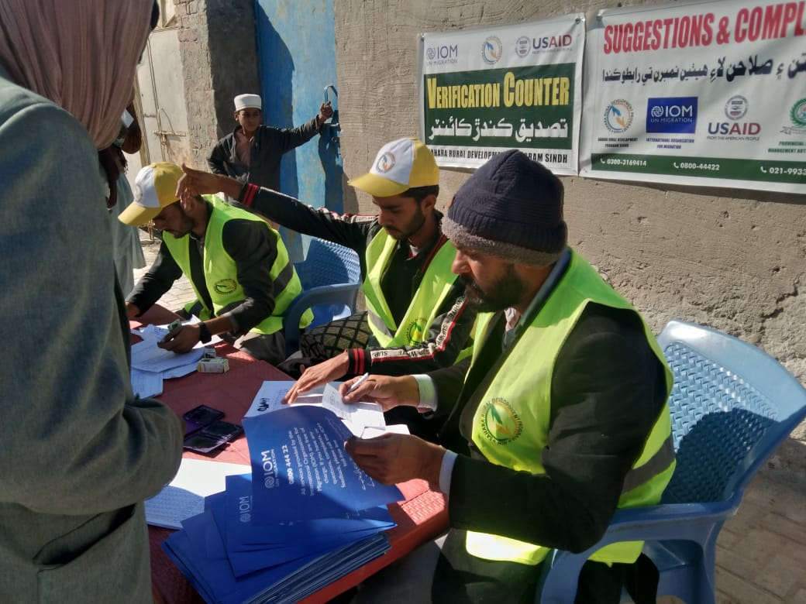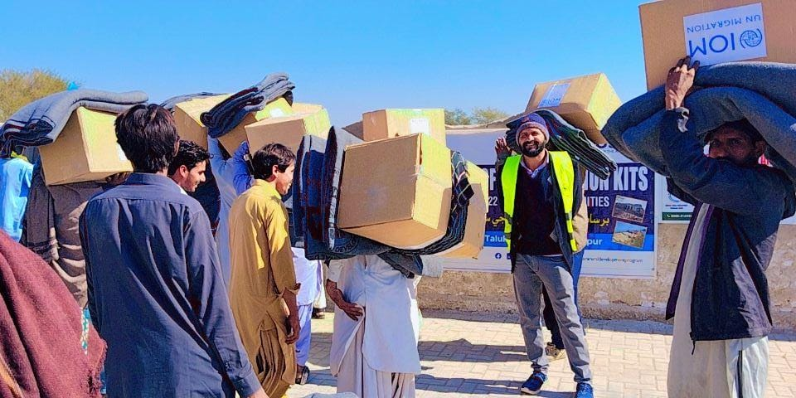
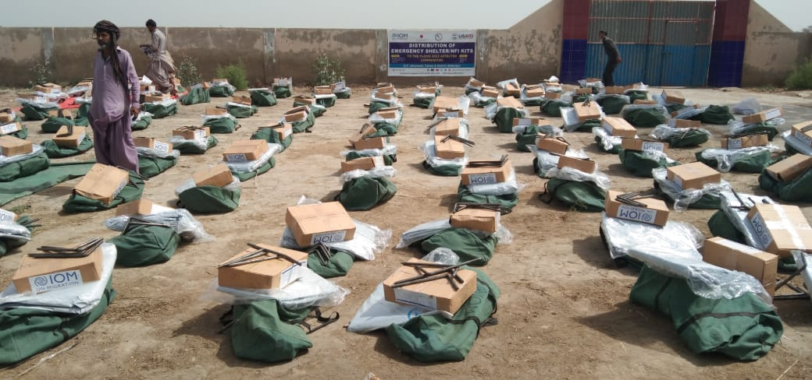
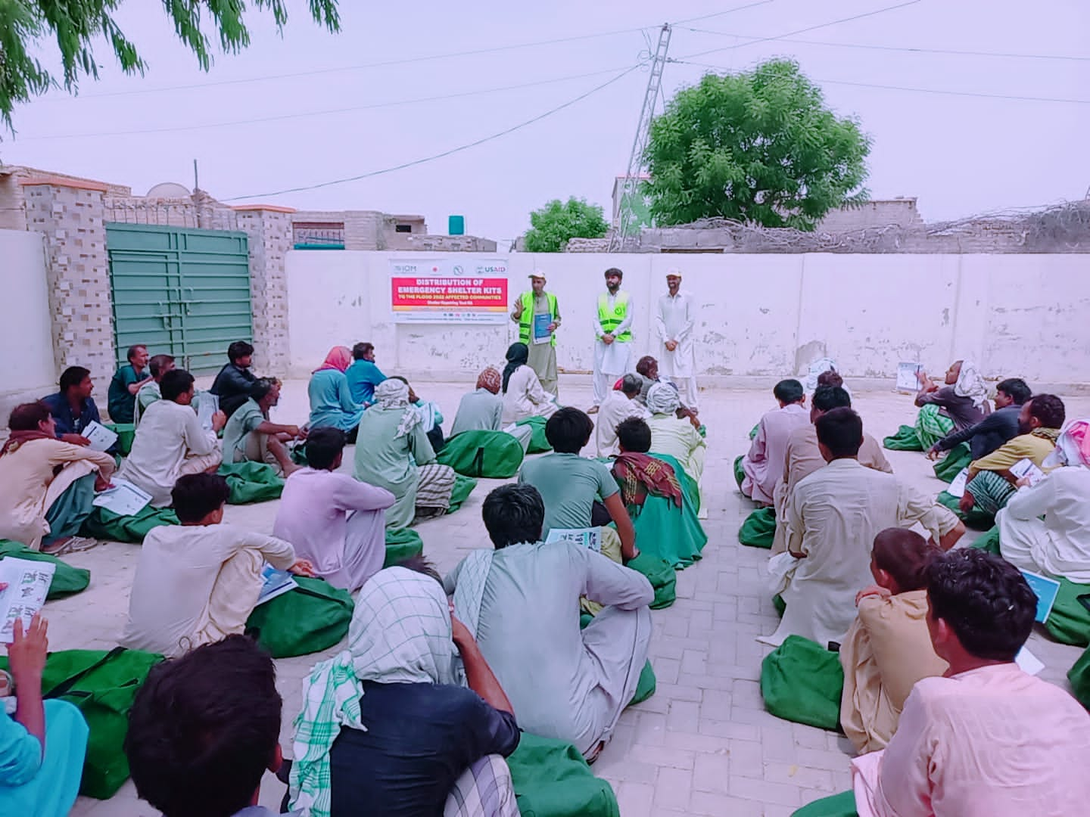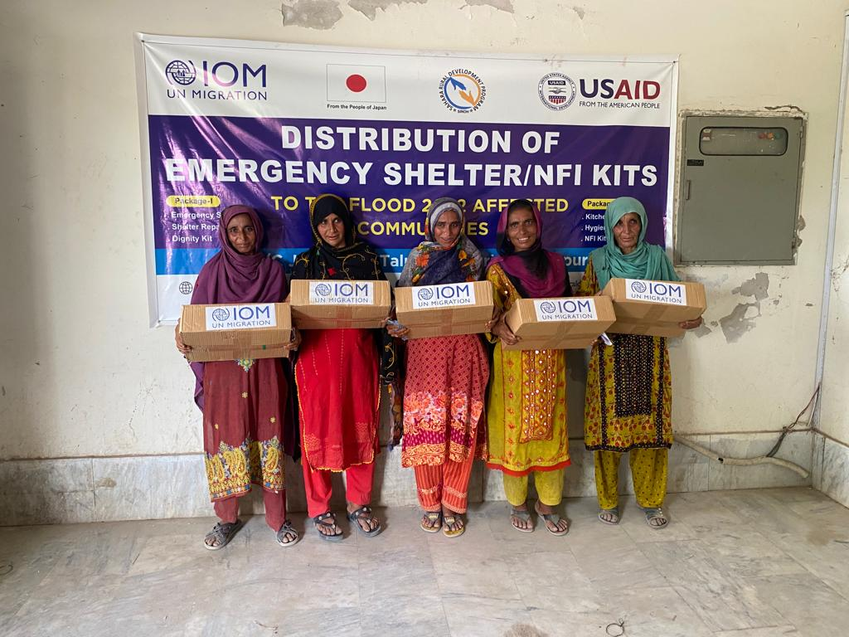
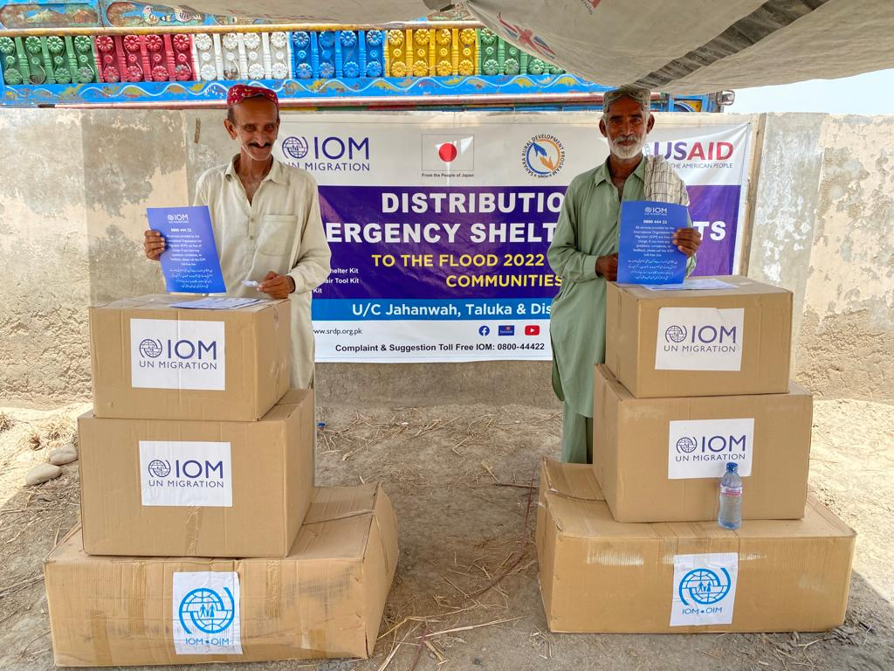
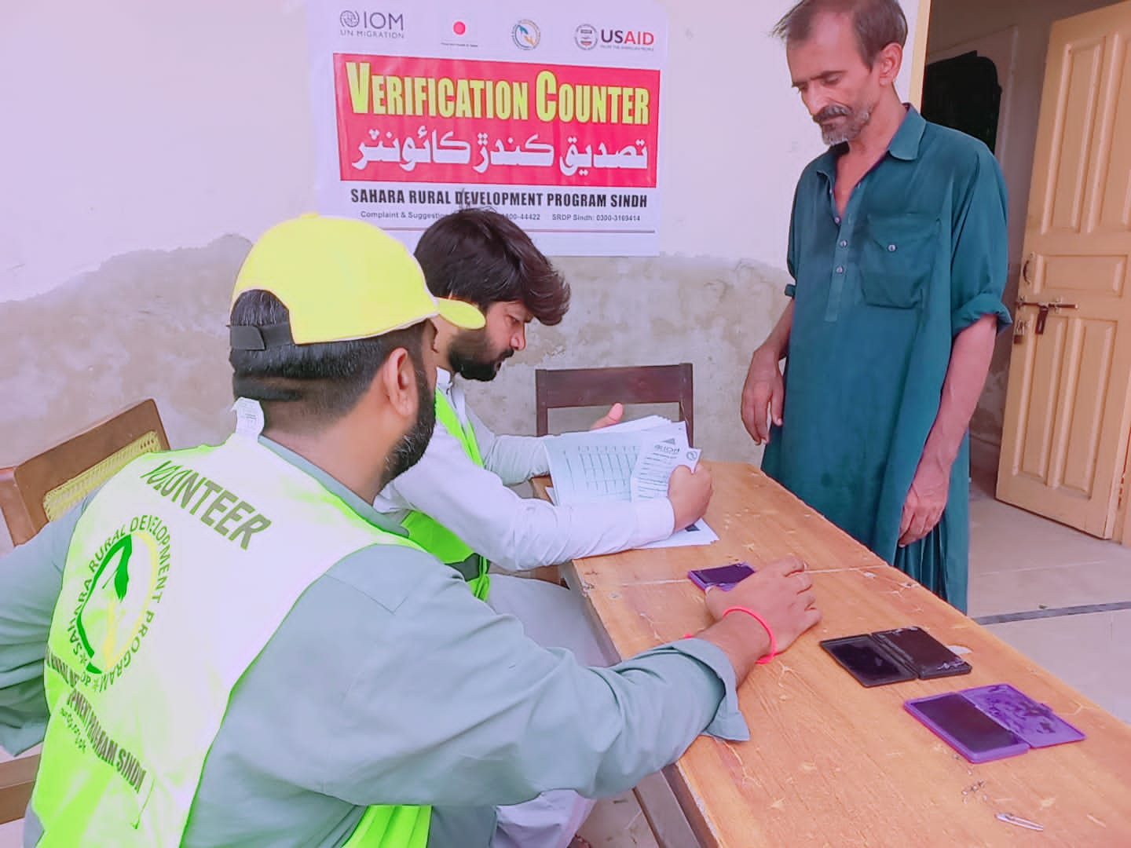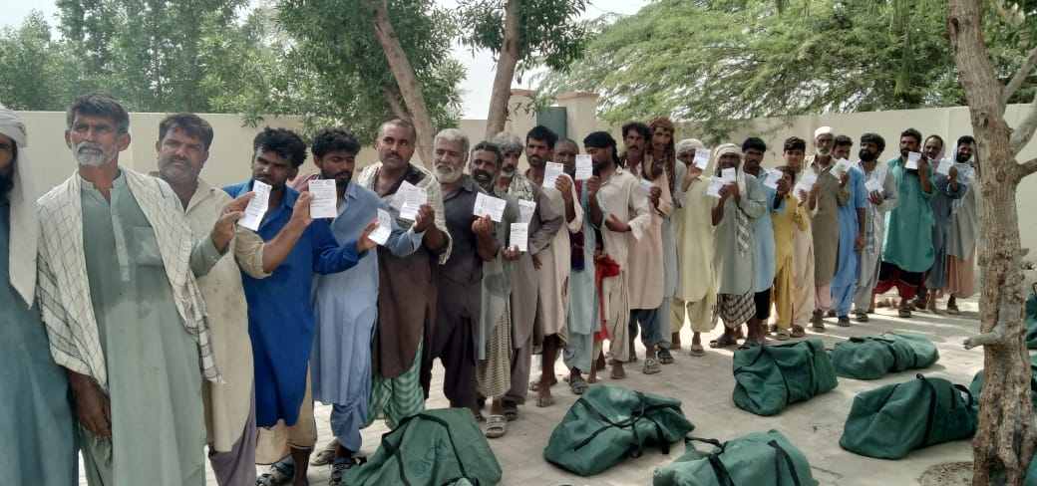

Contact Detail Offices SRDP Sindh.
Head Office
Office House No:20, Street No 04, Sector 01 Haroon Bahria Naval Colony Hub River Road Karachi.

Chairperson Raheema Ruby
Email: sahararuraldevelopmentprogramm@gmail.com
Cell # 0314-2006396

Field Office – Shikarpur
Office Misri Wahan Larkana by Pass Road Garhi Yasin
Taluka Garhi Yasin District Shikarpur Sindh

Email: sahararuraldevelopmentprogramm@gmail.com

Phone No# 0726-572224, Fax No: 0726-572225

Website: www.srdp.org.live

Mr. Riaz Ahmed Bhayo

Executive Director
Email: riazahmedsrdp@gmail.com
Cell # 0300-3169414

Field Office – Dadu
Office Address: Gareebabad Muhlla Near Ufone office Qambar.

Fahad Mehrab Chutto

Operation Manager

Email: fahadsrdp@gmail.com

Cell # 0300-349976

