**Shelter Sector Working Group Coordination**

**Minutes of 4th Meeting**

**Date:** 27 Sep 2022, Tuesday

**Time:** 14:00 hours

**Venue:** Online/In-Person

**Participants:** IOM, UNHCR, IFRC, UNDP, UNHABITAT, PPAF, Mercy corps, SRDP, HANDS, CESVI, Concern Rapid Fund, ALIGHT, ACTED, Courage foundation, ECHO, Islamic Relief Pakistan,

# PRIORITY ACTIONS

ACTION: IOM and all: registration for common pipeline is open: <https://commonpipeline.iom.int/> , distribution is in progress. IOM to report common pipeline data to UNOCHA on 5Ws tools

ACTION: Partners are agreed with the draft of revised appeal and will be share with UNOCHA.

ACTION: Final version of Kits documents will be share with partners

ACTION: PDM and ORS survey form will be share with partners

ACTION: TORs of Technical/Early recovery Working Group will be share for feedback and comments Partners to

# Decisions

**Decision:** To consider the early recovery, to have sustainable and resilience designs. The technical working group shall also work on different options for early recovery programing.

# Progress on action points from last meeting & Situation updates:

Partners **must sign up and regularly update 5w.**

LINK: partners to register for the 5w [here](https://forms.gle/tjdRzKLQVRQ21RPA8):

LINK: partners to report all distributions in 5w [here](https://docs.google.com/spreadsheets/d/1mPTxVhCtW-NHgAFtcScu9ptTKj99Ykm6y5-ObjBQ_DA/edit?usp=sharing):

LINK: Partners can **register for common pipeline** here: <https://commonpipeline.iom.int/>

The humanitarian response plan is accessible here: <https://reliefweb.int/node/3881170>.

It was issued 30 August and includes an appeal for 31 million USD for shelter, targeting 900,000 people from a total of 6.4million people in need. It was written when 950,000 houses were reported as damaged or destroyed.

Since then, the floods have impacted more people. The latest OCHA sitrep puts damage at 805,031 houses destroyed and 1,209,758 houses partially damaged the total houses damaged are above 2 million, more than double the figure when the appeal was launched.

Looking at the scale of emergency the revision of flash appeal is in consideration.

Shelter sector page on cluster website is activated <https://sheltercluster.org/response/pakistan-floods-2022>

# 5Ws and pipeline update

5Ws data was presented to the partners, The response is slow, and gaps/needs are huge. The submission of 5Ws process were explained to the partners. Partners were encouraging to regular update the 5Ws data, otherwise their efforts will not be reflected to govt and donors.

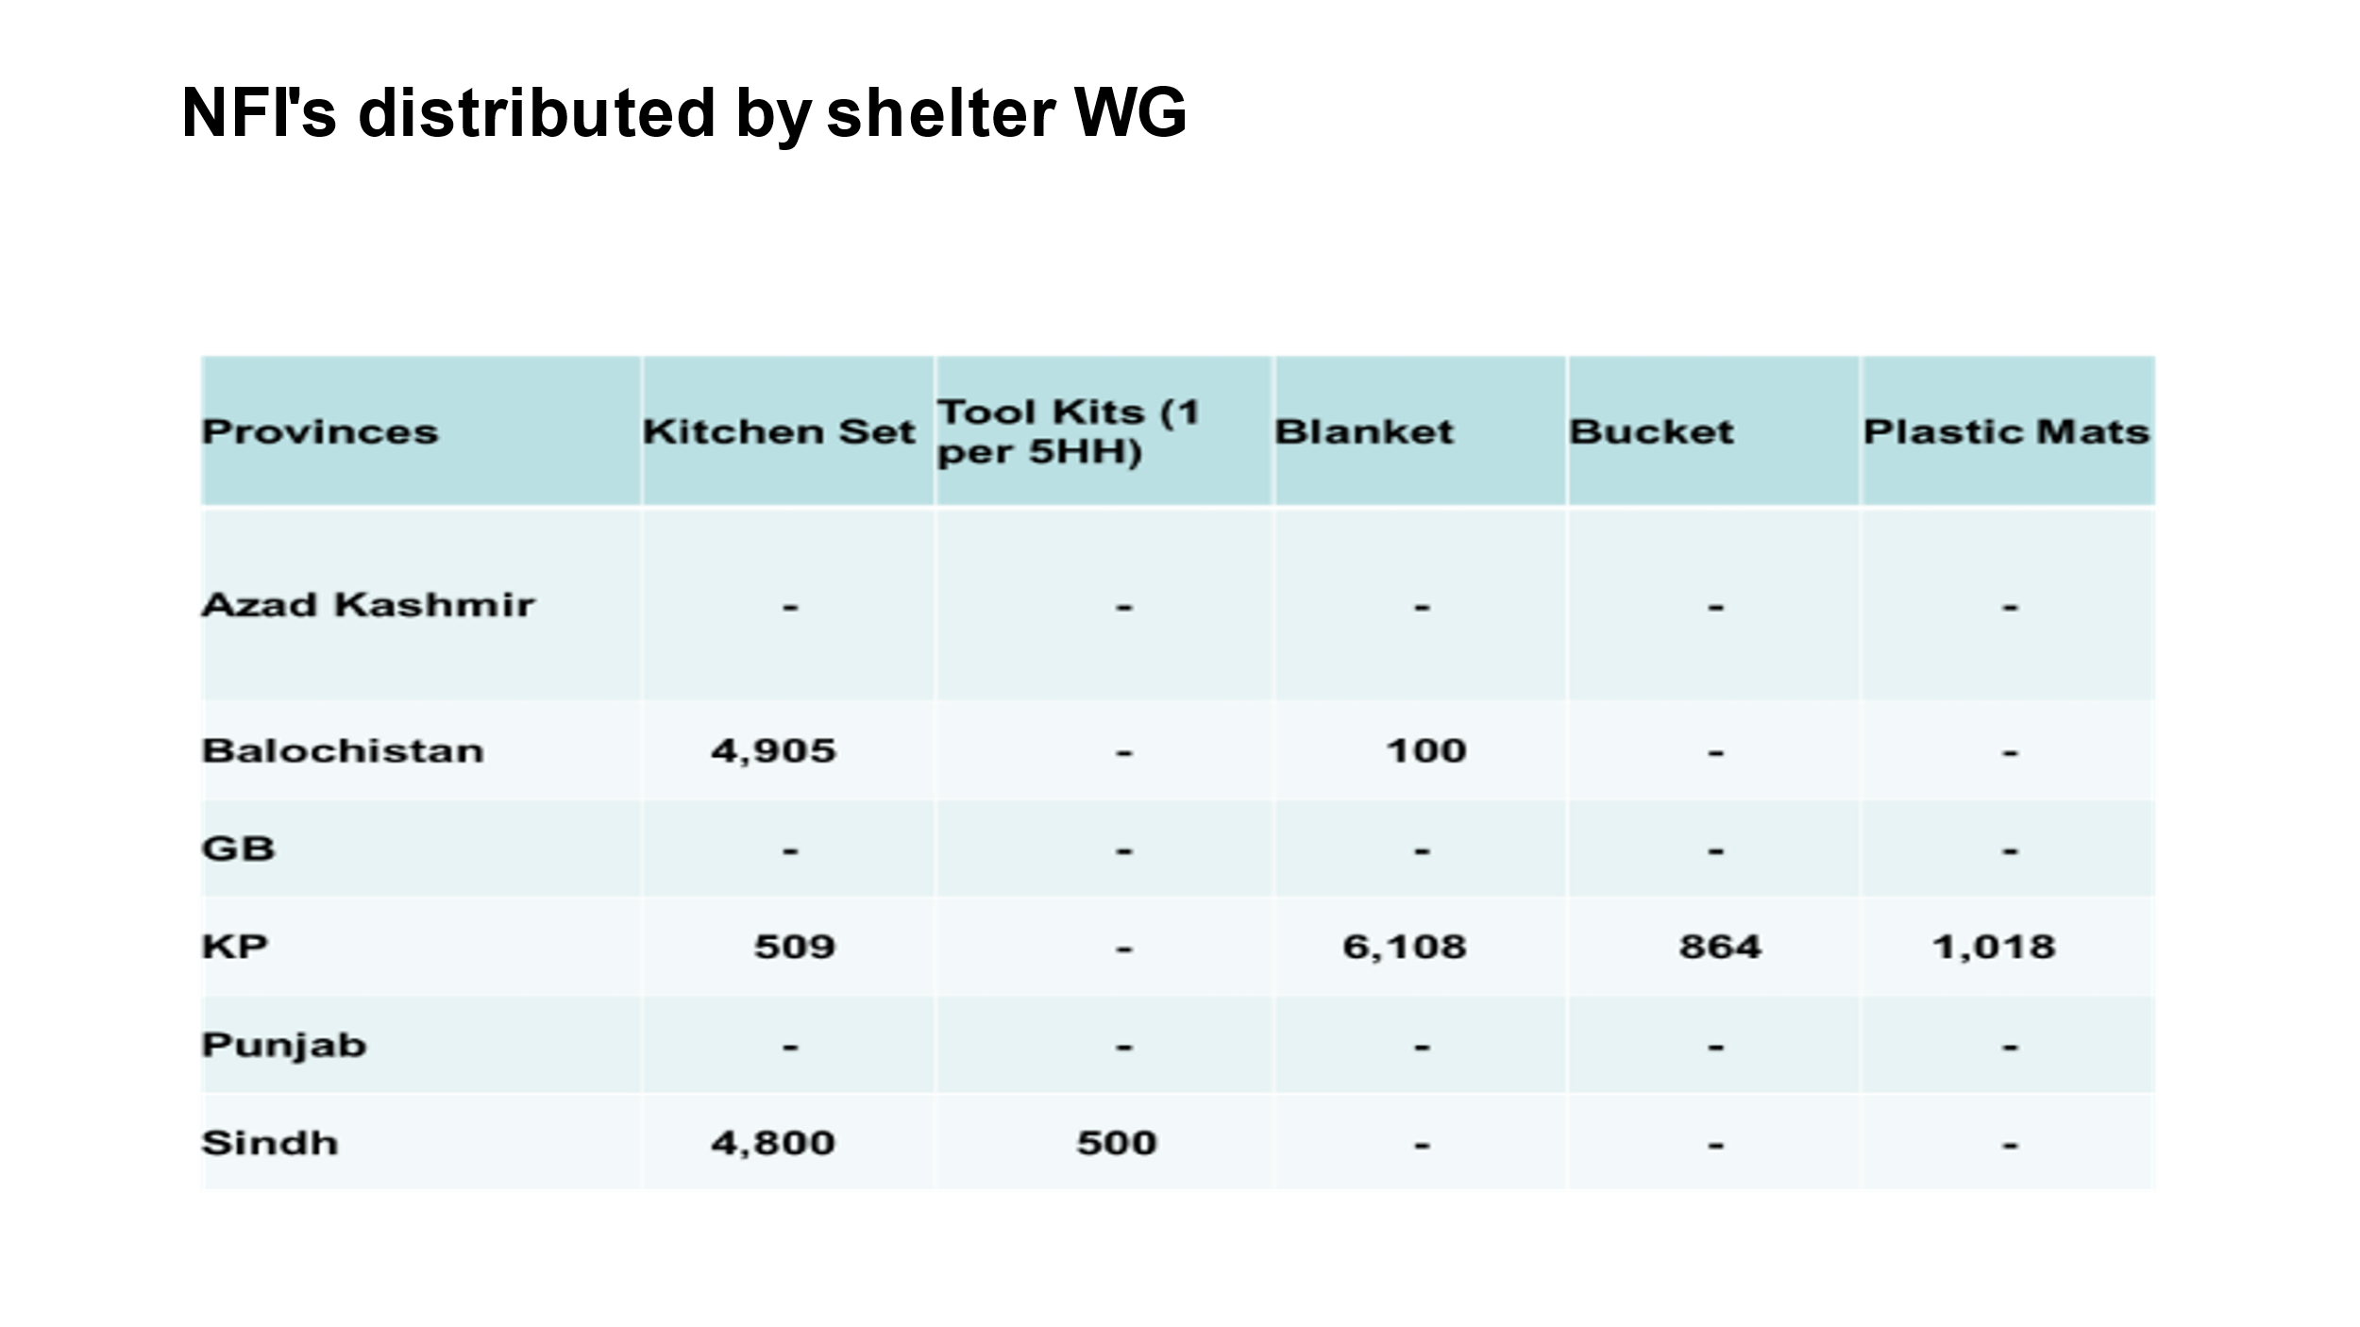

Partners were updated on the common pipline , it was mentoned that the registration request are very much high and the stock in the warehouse is limited. To evaluate the already submitted requestes new registrations on the tracking system is closed , partners will be informed once the registeration is open.

The revised appeal: DRAFT

Joseph Ashmore (IOM) presented the draft of revised appeal to the members. He thanks the sector members for the inputs and feedbacks. The assumptions, activities and targets were explained to the members. The appeal is very limited in scope, it focuses on emergency and winterizing. Revised appeal is very limited on early recovery. The revised appeal focuses on 34 of the affected districts out of 84-calamity declared districts.

The appeal is just a guiding line, which does not lead to any promise of funding sector members, and it does not mean that partner cannot seek additional funding, members shall keep their efforts to reach out to donors for securing funds.

Member are agreed with the revised appeal, sector lead shall submit this to UNOCHA.

Below is the extract of activities from the revised draft.

1. **Provide household item support and winter assistance:** Flood affected families have the basic items required for cold weather and to resume essential daily routines (like cooking and sleeping) in a dignified and appropriate manner. Target 20% of those whose homes were damaged or destroyed.
2. **Provide dignified emergency shelter assistance:** Flood affected families can build or improve their shelters (safe, covered living space) to provide at least a minimum level of safety, security, privacy, and dignity in displacement sites. Target 30% of those whose homes were damaged or destroyed.
3. **Provide support for dignified emergency shelter repairs and construction at return locations**: Support families returning as water recedes and can conduct emergency repairs and build resilient shelters to enable return as the waters recede. Target 10% of those whose homes were damaged or destroyed.
4. **Provide support and coordination to the management of Temporary Sites:** Ensure dignified conditions and protection for people living in collective settings by improving coordinated access to assistance, services, and safe living environments particularly from Gender-Based Violence (GBV). Target 30% of those residing in camps. This activity will also include DTM.

Discussion on Kits document

Last week we had an excellent meeting of the technical working group. About NFI kits, we decided to focus on the price rather than the items. And the concern was that if you're very precise on what the items are, then you'll all rushed to the same suppliers with the same demands. Which can lead to supply chain disturbance. So apart from high priority items the choice of secondary items is open while the price is locked.it give us leverage to customize the kits to the local context and requirement.

The kits document is revised with the updated composition of different kits. The revised document will be shared with members, The pricing will help partners in budgeting and programming.

Member raised the point “That they are working with the PDNA and there are one of the priorities is basically ensuring that whatever is constructed or produced is disaster and climate risk resilient because one of the reasons we are in this situation is of the climate change. So, regarding the construction of shelters, would there be any aspects of resilience in corporate into them or not”

The Technical working group can be termed early recovery working group, which can work on drafting the sector strategy for the recovery and work on the different design of ORS to incorporate the resilience and durability. UNDP express their availability for the group to work on durable solution for the relief and recovery phase.

The nomination is still open, and Partners are requested to nominate experience member. Special request to UNOPS, UNHABITAT and UNDP to become member of the working group.

## **ORS survey in SINDH & PDM questionnaire:**

IOM is conducting a survey in Sindh to check the response of ORS to the recent flood, the finding of survey will be share with partners.

PDM questionnaire is also developed, and it would be on the agenda in the next meeting. The PDM questionnaire along with revised Kits document will be share with partners.

## **Incident reported from Sindh:**

## 

There is an incident reported from Sindh that distribution was in progress and some beneficiaries, effected population from other union councils have the looted all the items. For managing the distribution properly, we will also share a document, a guideline and there is also some lesson learned from the incident that happened.

Increase engagement of local community leaders and volunteers in the distribution to mitigate such risk by giving community leaders the responsibility of security during the distribution time.

Partners are advised to have 1) distribution at multiple locations with small quantities and 2) start distributions early in the morning. This will reduce the quantity of items in one location as well as reduce having materials in one location for long time thereby reducing the risk of looting.

Distribution should be continued in other areas and the household registered in this area who has not received the materials due to this unfortunate incident can be called into other nearby distribution point for receiving the materials.

# Next meeting

This will be in hybrid format in Islamabad. Venue, time, and agenda will be shared later.