**Shelter Sector Working Group Coordination**

**Minutes of 5th Meeting**

**Date:** 4th Oct 2022, Tuesday

**Time:** 14:00 hours

**Venue:** Online/In-Person

**Participants:** IOM, UNHCR, IFRC, UNDP, UNHABITAT, PPAF, Mercy corps, SRDP, HANDS, CESVI, Concern Rapid Fund, ALIGHT, ACTED, Courage foundation, ECHO, Islamic Relief Pakistan, SFP, HDF, SIF, RDO, SDP, IHDF, Nishat Welfare Organization,

# PRIORITY ACTIONS

**ACTION:** IOM and all: registration for common pipeline is **closed for now**; <https://commonpipeline.iom.int/> ,distribution is in progress. IOM to report common pipeline data to UNOCHA on 5Ws tools

**ACTION:** Revised UNOCHA Flash Appeal will be shared with the partners.

**ACTION**: Volunteers for ORS Data Collection are required. Partners are requested to share the information for Sindh.

**ACTION:** Need active participation from partners for the Shelter Recovery Working Group.

**ACTION:** Final TORs of Technical/Early Recovery Working Group will be shared. Partners can share any kind of feedback.

**ACTION:** Multisectoral Rapid Need Assessment (MSRNA) report will be shared with the partners.

**ACTION:** Finalized Shelter/NFI Kits documents will be shared with the partners.

**ACTION:** “Compendium of key documents” will be shared with the partners.

**ACTION:** Shelter Sector will share the specifications for the winterized tents with the partners.

# Decisions

**Decision:** Data Collection for ORS will be conducted soon and inputs from technical working group for early recovery, to have sustainable designs will be required to complete it on urgent basis so that the early recovery programming kicks off.

# Progress on action points from last meeting & Situation updates:

Partners **must sign up and regularly update 5w.**

**LINK:** partners to register for the 5w [here](https://forms.gle/tjdRzKLQVRQ21RPA8):

**LINK:** partners to report all distributions in 5w [here](https://docs.google.com/spreadsheets/d/1mPTxVhCtW-NHgAFtcScu9ptTKj99Ykm6y5-ObjBQ_DA/edit?usp=sharing):

**LINK:** Partners can **register for common pipeline** here: <https://commonpipeline.iom.int/>

Shelter sector page on cluster website is activated <https://sheltercluster.org/response/pakistan-floods-2022>

# 5Ws and pipeline update

5Ws data is being updated regularly by the partners. However, partners are still encouraged to continue updating the data so that the efforts don’t go wasted and are reflected to the government and donors.

The Common Pipeline registarions are closed for now, partners will be informed once the registeration is open.

* The stock is replenished, the common pipeline team will reach out to registered sector members for submission of new requests or approve existing pending requests on the system.
* A new registration requirements and selection criteria will be circulated as well to sector members who wish to access future pipeline stocks.
* Individual requests through email will not be considered. Use the common pipeline tracking system for request
* Organizations that accessed the stock are kindly requested to upload their distribution reports using the common pipeline website no later than one week after the distribution completion dates. Delayed reports might affect the organization’s access to future stocks.
* Only active Shelter Sector members that attend the coordination meetings in Islamabad, Sukkur or Hyderabad will be able to access the upcoming pipeline stocks.

The Revised Appeal:

The initial appeal was issued on 30th August and includes an appeal for 31 million USD for shelter, targeting 900,000 people from a total of 6.4 million people in need. However, the revised flash appeal includes 145.5 million USD now targeting 12.6 million people in need and targeting around 3.5 million affected people.

The humanitarian response plan is accessible here: [Revised Pakistan 2022 Floods Response Plan: 01 Sep 2022 - 31 May 2023 (Issued 04 Oct 2022) - Pakistan | ReliefWeb](https://reliefweb.int/report/pakistan/revised-pakistan-2022-floods-response-plan-01-sep-2022-31-may-2023-issued-04-oct-2022) . the extract is :

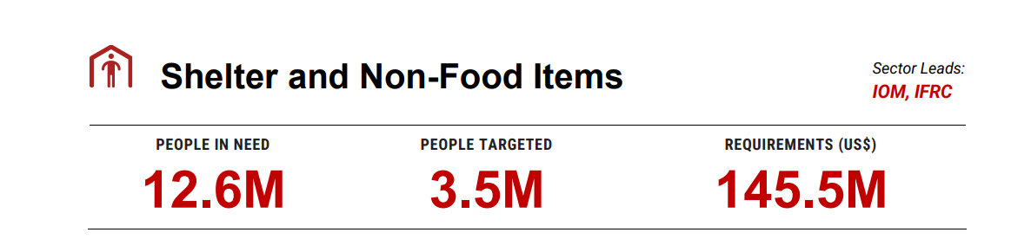

Below is the extract of activities from the revised draft.

1. Provide household item support and winter assistance: Flood affected families have the basic items required for cold weather and to resume essential daily routines (like cooking and sleeping) in a dignified and appropriate manner. Target 20% of those whose homes were damaged or destroyed.
2. Provide dignified emergency shelter assistance: Flood affected families can build or improve their shelters (safe, covered living space) to provide at least a minimum level of safety, security, privacy, and dignity in displacement sites. Target 30% of those whose homes were damaged or destroyed.
3. Provide support for dignified emergency shelter repairs and construction at return locations: Support families returning as water recedes and can conduct emergency repairs and build resilient shelters to enable return as the waters recede. Target 10% of those whose homes were damaged or destroyed.
4. Provide support and coordination to the management of Temporary Sites: Ensure dignified conditions and protection for people living in collective settings by improving coordinated access to assistance, services, and safe living environments particularly from Gender-Based Violence (GBV). Target 30% of those residing in camps. This activity will also include DTM.

ORS Data Collection

Partners are encouraged to volunteer for ORS activity for Sindh. UNDP express their availability for the group to work on durable solution for the relief and recovery phase. The technical early recovery group will work on strategies for recovery and sustainable designs for ORS.

Partners are requested to nominate experienced members for the group and participate actively.

Recovery Response Plan

Recovery will be happening very soon so the Shelter Recovery Working group will actively develop the strategies in coordination and feedback from partners. The group will help in providing guidance and developing training materials, conducting market surveys, and linking shelter activities with other sectors for provision of durable and sustainable solutions for the flood affected population.

Documents for Global Shelter cluster are available on [SC Pakistan Compendium of Key Documents](https://sheltercluster.s3.eu-central-1.amazonaws.com/public/docs/SC-Pakistan-Compendium-of-Key-Documents.pdf?VersionId=bXXWsp_PrcAn547MbiupjgCGXO.XvFsG) for all the partners.

Specifications for the winterized tents

Partners mentioned that for the coming winter season Winterized tents would be required by the flood affected people to protect them from the cold. Hence it was discussed that the sector will share the specifications for Winterized Tents with the partners and will be finalized once all agrees on it

Refugees Response plan (RRP)-2023:

UNHCR colleague Bilal Hassan provided brief to the partners on the RRP-2023. he shared that link to online form will be share with sector members, where the appealing agencies shall submit their plan. only the lead agencies are expected to submit while the Implementing partners shall coordinate with their lead agencies to incorporate their inputs. The template and guidelines will be share in the coming days.

# Next meeting

This will be in hybrid format in Islamabad. Venue, time, and agenda will be shared later. Partners are encouraged to participate in person in their respective locations.