# 2023/24 Shelter/NFI Winterization Strategy

**General**

Pakistan experiences Winter Season from November to February every year with snowfall mostly over Northern Regions. Likely hazards associated with winter include avalanches, landslides, cold waves, blizzards and fog in different parts of the country. Winter assistance needed in flood affected districts prone to cold weather, with at least 50% HHs in need of assistance. With climate change driven extreme weather patterns experienced during in the recent years including unprecedented Monsoon induced rains and floods in 2022/23, Cyclone Biperjoy in Sindh, Blizzard in Murree, heatwaves across the country, Shishper GLOF in Hasanabad, GB have caused colossal devastation across the country posing challenges to the humanitarian partners disaster management (DM) authorities at all tiers.

**Need**

There is an urgent need for winterization as part of preparedness in snow bound cold areas including districts GB, KP, and Balochistan which are prone to disasters (GLOFs, Rains, Snowfall, Blizzards). There is need for winterization to the 2022/2023 flood affected population, where some affected households have not received any assistance, and are at risk of the upcoming cold weather. Shelter and NFI support are a priority to protect flood-affected and vulnerable households, as well as communities prone to harsh winters from the elements. This Strategy advocates for an immediate response to these needs and provides recommendations on minimum winterization standards. Winterization standards include high priority items including blankets, quilts, warm shawls, warm caps, socks, cotton mattress, sleeping mats, and low priority items including fuel efficient stoves, warm cloths, tarpaulins, and mats.

In cold climates, with temperatures below freezing, people will die within one day without adequate protection from the elements. In addition, rain and wind increase heat transfer away from the body. Therefore, survival is often dependent upon prioritizing the distribution of NFIs to best provide thermal comfort *(Selecting NFIs for Shelter, IASC, Emergency Shelter Cluster, 2008)*

**Target districts**

As winter has arrived in most of the affected areas the timeframe for action is extremely limited. Districts in northern KP, Gilgit Baltistan and some areas of Baluchistan will face sub-zero temperatures in the coming months. Some of the flood affected districts in Punjab and Sindh will also be affected where communities have received minimum of no assistance.

(Referred to below as the ‘target districts’).

|  |  |  |
| --- | --- | --- |
| **Province** | **Prioritized districts** | **Criteria** |
| **Sindh** | Kambar-Shahdad-Kot, Larkana , Sukkur, Dadu, | * Districts affected by 2022/2023 floods with high impact and prone to cold weather. * Districts with high displacement due to 2022/2023 floods. * Elevation from sea level. * Areas that will most likely have extreme weather condition (snow bound areas i.e., North and Northwestern parts of country) * District inaccessible in winters hard to reach area due to snow or bad roads. * Poverty. |
| **KPK** | Kohistan (upper & lower), Chitral (upper & lower), Dir (upper & lower), Dera Ismail Khan, Tank |
| **Baluchistan** | Pishin, Qilla Saifullah, Quetta, dear Bhugti, Noshki, Loralai, Qilla Abdullah, Mastung, Ziarat, Zhob |
| **Punjab** | Rajan Pur, Dera Ghazi Khan |
| **GB** | Ghizar, Astoor, Diamar, Skardu, Upper Hunza. |
| **AJK** | Neelum, Leepa Vally, Havali |  |

**Winterization approaches**

To maximize assistance and protection for those in need, the Winterization Strategy for Shelter & NFI advocates that the following three approaches be undertaken simultaneously:

### Accelerated and increased distribution of winterized emergency shelter & NFI kits (see Annex A)

Sector partners to ensure distribution of available winter kits before severe cold weather starts, and to ensure timely procurement of kits to expand coverage in a timely manner.

### Provision of winterized Transitional Shelter (see Annex B)

Certain Shelter sector members have experience of implementing winterized transitional shelter programs in Pakistan. Partners with winterized shelters stocks, capacity, access and experience needs to focus on snow bound areas e.g., Chitral, and districts in GB for timely provision of shelters.

1. **Identification of alternative solutions including collective centers**

As part of winter preparedness in areas with minimum shelter assistance or prone to extreme cold weather, the sector partners to coordinate with local authorities to identify collective centers/public buildings where families can be sheltered during the winter months incase winter gets harsh.

**Shelter Priorities for Winterization**

As minimum standards, assistance should support households to have a structurally safe shelter with an average temperature of 18c, free from leaks and drafts. The Shelter Sector has developed priorities along with and corresponding activities with a winterization focus.

* **Minimum package of essential household items**

The key shelter priority is to keep the immediate space around bodies warm. This is provided primarily by **warm clothes** and

**bedding**. The key needs are for **blankets**. The secondary shelter priority is to provide protection from the elements, by providing a **waterproof roof**. Adequate Drainage is also needed, so **tools** are needed to help prevent tents from flooding.

* **Winterization key messages**

Shelter partners to coordinate with Shelter Sector on disseminating key messages for winterization: dress right; stay active; fire safety; conserve energy, heat appropriately and protected from floods; maintain your shelter; and considerations for vulnerable individuals. At the ISWG level Health and education sector to support through advocating in different facilities.

* **Prevent heat loss from the shelter.**

Through applying different techniques and conducting community outreach to access as many households as possible in the targeted areas. The key techniques including Ground insulation and bedding are key in preventing heat loss to the ground and will help survival through periods of cold. **Providing thick quilts or high-quality** blankets can provide personal insulation from the ground, whilst closed cell foam, or raised wooden floors will reduce this heat loss. **Plastic sheeting** is a key basic flooring component preventing rising damp.

To ensure a warm living environment, wind proofing is essential. Draughts can be blocked by **plastic sheeting**, **canvas**, or **blankets** over gaps. Draughts can also be blocked at ground level by **building low walls** (or excavating downwards if there is no risk of flooding). Additional **Tools** may be required to complete this.

* **Provision of stoves**

Provision to the most vulnerable households in the targeted locations. Safety measures will be taken into consideration through the entire process. The use of stoves to heat internal spaces is dependent on the fuel availability, and choice of stove must consider where the fuel comes from. Cooking and heating functions of stoves should be considered separately, and care needs to be taken with reducing fire risk. Smoke is a common cause of respiratory infections and eye disease. Care should also be taken with toxic exhaust gases such as carbon monoxide build up. *(Selecting NFIs for Shelter, IASC, Emergency Shelter Cluster, 2008)*

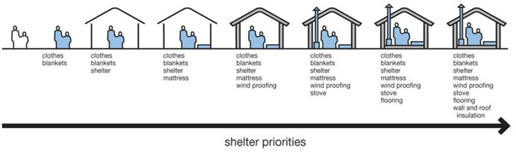

**Winters-2023/24 Visualized contingency Scenarios.**

Visualized contingency scenarios derived from PMD’s (Pakistan Meteorological Department) Outlook for Monsoon-2022/23 are as under.

**Scenario-1 (Most Likely) - Normal to Below Normal**

* Less rainfall / snow in northern parts of country; Khyber Pakhtunkhwa, Gilgit Baltistan, Punjab (Murree) and AJ&K.
* Nearly Normal / beneficial rainfall in respective southern parts of the country; Southern Punjab and Sindh, whereas Balochistan to have nearly normal rainfall and snowfall in higher altitudes / mountainous areas.
* Temperatures decline on a steady scale during winters.
* Development of fog / mist in low-lying / plain areas of the country.
* Dust-raising windstorms likely/ expected in Southern Punjab and Northern Sindh.
* Extreme winter events (blizzards, cold waves, ice-storms, hailstorms) considered less-likely, however, cannot be ruled out entirely.
* Expectation of temperatures remaining “above normal” in northern parts of the country may lead to avalanches in vulnerable areas where snow on slopes may have weakened / destabilized.
* Likelihood of flash flooding in parts of Balochistan, where soil is already saturated and many check dams were damaged.
* Cold and relatively dry weather conditions will exasperate the smog conditions, further reducing the air quality index of affected areas.

**Scenario- 2 (Likely) - Normal**

* Normal rainfall / snow in northern parts of the country; Khyber Pakhtunkhwa, Gilgit Baltistan, Punjab (Murree) and AJ&K.
* Nearly Normal / beneficial rainfall in respective southern parts of the country; Southern Punjab and Sindh, whereas Balochistan to have nearly normal rainfall and snowfall in higher altitudes / mountainous areas.
* Temperatures remain close to average temperatures during the winter season.
* Development of fog / mist in low-lying / plain areas of the country to be prevalent during earlier part of the season.
* Dust-raising windstorms with less intensity likely in Southern Punjab and Northern Sindh.
* Dry-cold weather conditions will exasperate the smog situation in Punjab further reducing the air quality index of affected areas.
* Potential cold waves to exasperate winter situation nationwide causing rapid decrease in temperatures and increasing strain on heating fuel for homes.
* Likelihood of flash flooding in parts of Balochistan, where soil is already saturated and many check dams were damaged.
* Wet spells in colder temperatures may lead to freezing rains / ice-storms in upper parts of the country which may jeopardize above-ground electrical lines due to icing. Furthermore, roads may experience forming “black ice” making driving conditions hazardous / slippery.

**Scenario-3 (Less Likely)** **- Above Normal**

* Above Normal rainfall / snowfall in northern parts of the country; Khyber Pakhtunkhwa, Gilgit Baltistan, Punjab (Murree) and AJ&K.
* Normal rainfall in respective southern parts of the country; Southern Punjab and Sindh, whereas Balochistan to have nearly normal rainfall and snowfall in higher altitudes / mountainous areas.
* Temperatures will decline at an increased pace during winter season.
* Development of fog / mist in low-lying / plain areas of the country will be experienced during earlier part of the season.
* Dust-raising windstorms will be less likely Southern Punjab and Northern Sindh.
* Likelihood of flash flooding in parts of Balochistan, where soil is already saturated and many check dams were damaged.
* Potential cold waves to exasperate winter situation nationwide causing rapid decrease in temperatures and increasing strain on heating fuel for homes.
* Wet spells in colder temperatures may lead to freezing rains /ice-storms or hailstorms in upper parts of the country which may jeopardies above-ground electrical lines due to icing. Furthermore, roads may experience forming of “black ice” making driving conditions hazardous / slippery.
* Heavy snowfall in northern parts of the country; Khyber Pakhtunkhwa, Gilgit Baltistan, Murree Region, higher altitude / mountainous areas of Balochistan and AJ&K, which may cause road closures and possible damage to communication infrastructure (roads and telecom)

**Winters-2023/24- Shelter NFI CCCM Sector Preparedness**

Shelter NFI CCCM Sector timely initiated winter 2023/24 preparedness in the last week of September 2023, considering start of winter season in North KP, Balochistan and GB. The following measures have been taken by the sector so far.

* **Winter strategy development**

Winter strategy at National level developed, and has been presented at ISWG meeting, and HCT Meetings. It will also be shared with the key stakeholders including partners, Government, N/PDMAs.

* **Winter stocks mapping**

[Winter_Contingency_Stock_Mapping_09Oct23.xlsx](https://iomint-my.sharepoint.com/:x:/g/personal/muhammadkhan_iom_int/EYar4IuPzt5OpsnKsoMFYaABKTL8N9PFQ0cdgkl_fpr30w?email=ssraza%40iom.int&e=Z336yp) has been completed and the summary is given below.

|  |  |  |  |
| --- | --- | --- | --- |
| **Potential Coverage** | | | |
| **Items** | **Stock** | **HHs** | **Individuals** |
| **Blanket** | 29,860 | 4,266 | 29,860 |
| **Quilts** | 7,496 | 1,071 | 7,496 |
| **Warm Cloth** | 21,650 | 3,093 | 21,650 |
| **Winterization Kit** | 97,705 | 97,705 | 683,935 |
| **Stoves** | 9,500 | 9,500 | 66,500 |
| **Total** | **166,211** | **115,634** | **809,441** |

* **Winter coordination meeting and partners mobilization**

Dedicated meetings conducted in wake of upcoming winters; partners capacity has been mapped. So far 31 partners throughout the country have shown interest in terms of resources, preparedness, and access. Details in the stocks mapping. Further coordination has been effectively established with relevant government at National and Provincial levels.

* **Information management and data sharing**

The sector is compiling updated information and data through utilization of various tool including 5W matrix, dedicated winter sticks and partners mapping to avoid duplication and identify the most vulnerable and affected areas.

* **Technical guidelines for winterization**

Guidelines developed including details and specification of winter kit and shelter. Guidance also develops on wind proofing and prevention of heat loss of existing shelters.

* **Early warning**

The sector will be timely sharing early warning received from PMD and NDMA on regular basis with partners through winter season. The sector will remain in coordination with relevant partners including government entities at district, hub, provincial and National levels.

**Annex A: Recommended Winterization Kit.**

The underlined items provide winterized support.

|  |  |  |
| --- | --- | --- |
| **NFI KITS** – suggested.  Jerry cans/ hygiene kits/ mosquito nets etc. are not included as they are covered by the WASH and Health Clusters | | |
| High priority | Blankets* | 4 single or 2 double (Northern areas) |
| 3 singles (Southern areas) |
| Warm shawls | 2 adult, 4 children |
| cotton mattress | 1 |
| Sleeping mat | 1 |
| Lower priority | Fuel efficient cooking stove** (with access to appropriate  fuel) | 1 |
| Clothes*** (fabric and sewing kit preferable to clothes) | 1 |
| Floor sheets or ground mats | 1 |

* Fewer blankets are required in southern areas.

** In previous emergencies in Pakistan, fire outbreaks in tents and temporary settlements have led to the banning of stove distribution. All stoves and lamp distribution programs should be accompanied by fire safety public information and preparedness.

***In the immediate aftermath of the flooding, clothes are a significant need. However, to reach coverage of the largest number of families there will be delays in distribution.

Suggested clothing package:

* Winter Jacket Adult (M or L)- 3 units
* Winter Jacket Children (children M)- 4 units
* Winter undergarments for Children (children M)-4 sets
* Socks Adults- 6 pairs
* Socks for Children (children S-M) 8 pairs
* Warm Cap Adults- 2 units
* Warm Cap Children (children S-M)- 4 units
* Ladies winter shawl- 2 units

Technical ⃒**2010**

# 

# **Annex B: 2023 Winterized Shelter Technical Guidelines**

## **→** Winterized Tent

A winterized tent must be made of waterproof canvas and must have a strong supporting frame. It must provide a minimum of 12m2 (130sq.ft.) covered area. Additionally, a winterized tent has the following components:

### Fly sheet

Separate fly sheet, usually made from canvas, which fits over the inner tent.

### Flue manifold:

The inner tent and flysheet each have a metal plate with a hole in it. These plates are sewn in or fixed into a canvas pocket. This allows for a stove with a chimney to be placed inside the tent without the risk of the flue pipe igniting the canvas when hot.

### Structural supports:

The poles which form the vertical supports, and the ridge beam should be made of a thick gauge steel (min 1.5mm) and with an external diameter of 35-50mm. This gives suitable structural resistance to both high winds and snow loading.

### Inner lining:

The inner tent may have a light cotton (‘desouti’) lining.

### Mud flaps / valences:

The tent must have rotproof mud flaps of suitable quality and length to allow the tent to be dug into the ground.

The following graphic illustrate1 and example of how plastic sheeting, rope and sandbags may be used to winterize a tent:

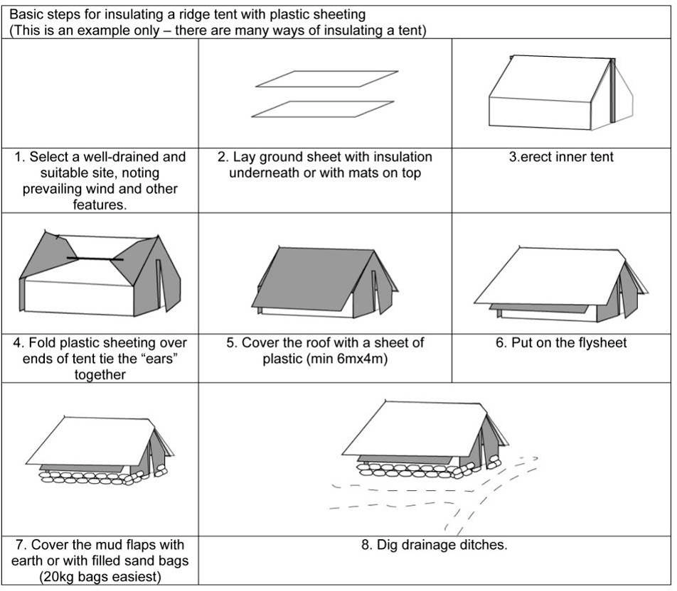

## 

## **→ Winter Adaptation of Tents by Beneficiary**

Beneficiaries can upgrade tents in many ways. Sensible adaptations should be encouraged. Observed strategies adopted by beneficiaries from previous response include:

* Raising floors with timber or stone to reduce draughts and increase insulation.
* Digging in of valences /mud flaps to reduce drafts and risk of flooding.
* Construction of low walls, potentially head height walls to increase thermal mass and reduce drafts.
* Use of plastic sheeting or blankets over closed ends of tent to reduce drafts.
* Use of stoves for cooking and heating at key times of the day when cold is most intense.
* Excavating the interior space of tents to reduce ground level drafts where there is adequate drainage.

## **Kit for Winterization**

## Upgrading of Tents

The basic materials required to winterize a tent are plastic sheeting and rope with blankets and floor insulation for personal shelter. Below are the priority items that a family will need to provide for tent winterization. The remaining materials to be distributed will depend on what families have already possess2:

* Minimum 2 high quality wool blankets **per family** (minimum TOG value of 2.0). If high quality synthetic blankets (generally brightly patterned fleece type material) or thick quilts are used, fewer than 2 may be

used. Mattresses are the preferred form of ground insulation but are subject to logistics constraints.

**sphere NFI standard 1 guidance note 3:** “*Provision of insulated sleeping mats to combat heat loss through*

*the ground may be more effective than providing additional blankets”*

** plastic sheeting - (OXFAM/MSF quality preferred, reinforced with bands) to wrap the tent and cover

the floor. This corresponds to two or three 6mx4m plastic sheets.

*** clothes **must be winter clothes**, clean, compressed, sorted by age/size and gender and culturally appropriate.

**sphere NFI standard 1 guidance note 3:** “*Changes of clothing: individuals should have access to*

*sufficient changes of clothing to ensure their thermal comfort, dignity and safety. This could entail the*

*provision of more than one set of essential items, particularly underclothes, to enable laundering*”

**** general ground insulation reduces ground heat losses. Partially flooring a room with blankets and plastic sheeting will allow people to sit reducing direct conductive heat loss.

Note that sandbags may also be used

in the construction of basic walls.

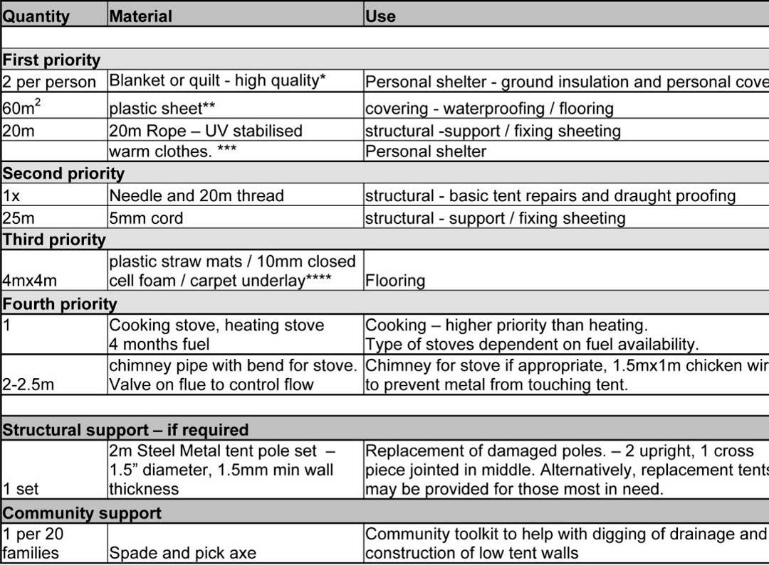

# **Fire Safety recommendations for temporary settlements**

Source: Shelter Cluster Pakistan - Dec’05-Jan 06

