**Shelter Sector Working Group Coordination**

**Minutes of 3rd Meeting**

**Date:** 20 Sep 2022, Tuesday

**Time:** 14:00 hours

**Venue:** Online/In-Person

**Participants:** IOM, UNHCR, UNHABITAT, CESVI, CORE Response, Concern Rapid Fund, CRS, SRDP Sindh, ALIGHT, ACTED, CARD, Islamic Relief Pakistan, NRSP, Red cross, Muslim Aid, Roshni development fund (RDF), SDP, HANDS, Concern Worldwide, SHIFA Welfare Association, DIN Sindh, IFRC, Courage Development Foundation.

# PRIORITY ACTIONS

ACTION: IOM and all: registration for common pipeline is open: <https://commonpipeline.iom.int/> , distribution is in progress. IOM to report common pipeline data to UNOCHA on 5Ws tools

ACTION: Draft TORs of Technical Working Group will be share for feedback and comments

ACTION: Partners to nominate members for Technical Working Group

ACTION: ACTED will host the next meeting.

# Decisions

**Decision:** Partners agree to have one tarpaulin in Emergency shelter kit for Sindh to facilitate more beneficiaries with limited resources.

# Progress on action points from last meeting & Situation updates:

Partners **must sign up and regularly update 5w.**

LINK: partners to register for the 5w [here](https://forms.gle/tjdRzKLQVRQ21RPA8):

LINK: partners to report all distributions in 5w [here](https://docs.google.com/spreadsheets/d/1mPTxVhCtW-NHgAFtcScu9ptTKj99Ykm6y5-ObjBQ_DA/edit?usp=sharing):

LINK: Partners can **register for common pipeline** here: <https://commonpipeline.iom.int/>

The humanitarian response plan is accessible here: <https://reliefweb.int/node/3881170>. It was issued 30 august and includes an appeal for 31 million USD for shelter, targeting 900,000 people from a total of 6.4million people in need. It was written when 950,000 houses were reported as damaged or destroyed.

Since then, the floods have impacted more people. The latest OCHA sitrep puts damage at 782,274 houses destroyed and 1,155,457 houses partially damaged the total houses damaged are 1.95Million, more than double the figure when the appeal was launched.

The scale of emergency is huge compared to the 2010 flood. Response from the humanitarian partners is slow. UNOCHA might revise the humanitarian response plan.

Shelter sector page on cluster website is activated <https://sheltercluster.org/response/pakistan-floods-2022>

# 5Ws and pipeline update

5Ws data was presented to the partners, The response is slow, and gaps/Needs are huge; Sector has coordinated with UNOCHA.an improved 5Ws tool is now available. Partner must regularly share the data.

Note if you do not report in the 5W we cannot share your good work and donors will have no visibility of your activities.

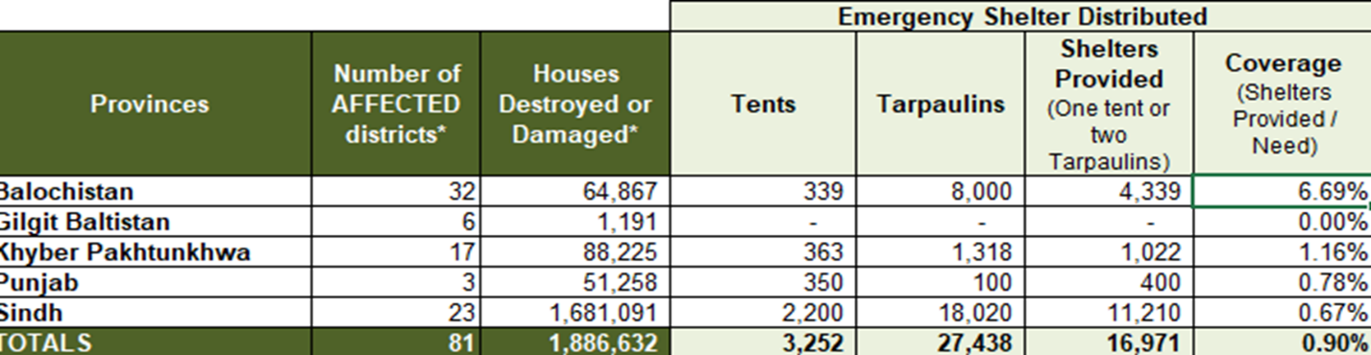

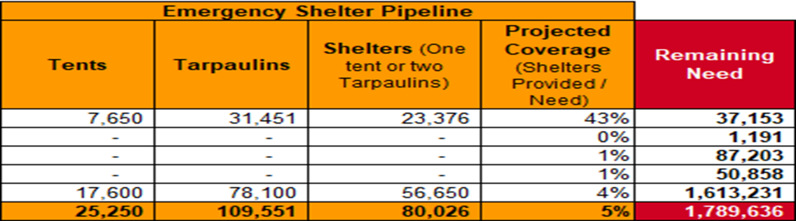

Sector updates from Sindh

General situation:

Joseph Ashmore (IOM) Joined from Sindh and provided an update to the partners on the response. “Distributions from Sukkur Hub have started; however the response is slow; the gaps remain enormous. While traveling, we observe that majority of the households we've seen have had no visible assistance in terms of shelter. Whilst the gap needs to be validated, the gaps are huge, and the needs are very, very significant in large areas. High proportions of the land are still flooded. We've been driving for, 6 hours today and we're still surrounded by floodwater.”

Most visible people are in spontaneous sites along roadsides. Though others have moved in with host households.

A court order has been made relating to the response and includes the formation of camps with the intention to shift people to them.

District level coordination updates: The 1st sectoral meeting outside of national / Provincial capitals was held in Sukkur on 19 September. A meeting in Hyderabad will be held on Wednesday 21st and for Karachi meeting is planned on Friday 23rd. Active partners are encouraged to actively participate in the meetings.

Feedback on Kits document

The sector shared a draft document on 18th September entitled: “DRAFT 1.0: Shelter and NFI kits and specifications for 2022 Pakistan floods.” This document provides definitions and detailed description of the different types of shelter and NFI assistance recommended by the Shelter Sector in Pakistan.

ACTED, Muslim Hands and Rapid funds have shared their NFI/Shelter kits composition for reference and updating the guideline documents. Other partners show their agreement with the contents of the living document.

To finalize the kits partners have nominated technical persons for the technical working group. The following organization has nominations

* Hands- Shahid Noonari
* CRS- Gul Wali Khan
* Concern Rapid Fund-Amir Malik
* ACTED-Yousaf Aziz
* Islamic Relief Pakistan-Arsala Khan

1st meeting of the technical working group is on Thursday 22nd Sep- the venue and time will be shared later.

## **ONLY One Tarpaulin per kit**

One tarpaulin per kit was agreed in the coordination meeting Sukkur as an emergency measure. This was agreed in Islamabad. This was due to:

* needs being far greater than supply
* sites being very dense – larger shelter sizes will lead to evictions

However:

* agencies will aim for additional tarpaulins per HH to bring the standard up to two per HH as soon as basic coverage of 1 tarp per HH is reached

AND

* The decision to provide one tarpaulin per HH will be highlighted as agencies failing to meet normal humanitarian standards for this response. It will be used as an indicator that the response is under resourced and an advocacy point to donors.

# Next meeting

This will be in hybrid format in Islamabad. ACTED express their willingness to host the next meeting.