# 2023/24 Shelter/NFI Winterization Strategy

**General**

Pakistan experiences Winter Season from November to February every year with snowfall mostly over Northern Regions. Likely hazards associated with winter include avalanches, landslides, cold waves, blizzards and fog in different parts of the country. With climate change driven extreme weather patterns experienced during in the recent years including unprecedented Monsoon induced rains and floods in 2022/23, Cyclone Biperjoy in Sindh, Blizzard in Murree, heatwaves across the country, Shishper GLOF in Hasanabad, GB have caused colossal devastation across the country posing challenges to the humanitarian partners disaster management (DM) authorities at all tiers.

**Need**

There is an urgent need for winterization as part of the response to the Pakistan floods and snow bound areas, as extreme weather in certain affected areas may further endanger lives. Shelter and NFI support are a priority in order to protect flood-affected and vulnerable households, as well as communities prone to harsh winters from the elements. This Strategy advocates for an immediate response to these needs and provides recommendations on minimum winterization standards.

In cold climates, with temperatures below freezing, people will die within one day without adequate protection from the elements. In addition, rain and wind increase heat transfer away from the body. Therefore, survival is often dependent upon prioritizing the distribution of NFIs to best provide thermal comfort *(Selecting NFIs for Shelter, IASC, Emergency Shelter Cluster, 2008)*

**Target districts**

As winter has arrived in most of the affected areas the timeframe for action is extremely limited. Districts in northern KP, Gilgit Baltistan and some areas of Baluchistan will face sub-zero temperatures in the coming months. Some of the flood affected districts in Punjab and Sindh will also be affected where communities have received minimum of no assistance.

(Referred to below as the ‘target districts’).

|  |  |  |
| --- | --- | --- |
| **Province** | **Prioritized districts** | **Criteria** |
| **Sindh** | Kambar Shahdad Kot, Larkana , Jacobabad, Khairpur, Sukkur, Dadu, Umer Kot,  Kashmore, Tharparkar , Thatta and Sujawal (costal belt only) | * Most affected – high Damages * Displacement * Elevation from sea level * Extreme weather condition (snow bound areas) * Inaccessible (hard to reach area) * Poverty |
| **KPK** | Kohistan (upper & lower), Chitral (upper & lower), Dir (upper & lower), Dera Ismail Khan, Tank |
| **Baluchistan** | Pishin, Qilla Saifullah, Quetta, dear Bhugti, Noshki, Loralai, Qilla Abdullah, Mastung, Ziarat, Zhob |
| **Punjab** | Rajan Pur, Dera Ghazi Khan |
| **GB** | Ghizar, Astoor, Diamar, Skardu, Upper Hunza. |

**Winterization approaches**

To maximize assistance and protection for those in need, the Winterization Strategy for Shelter & NFI advocates that the following three approaches be undertaken simultaneously:

### Accelerated and increased distribution of winterized emergency shelter & NFI kits (see Annex A)

Standard winterization kit including blankets, bedding and mattresses have been part of the recommended NFI kits since the beginning of the emergency response. However, a significant gap remains in the target areas*. The Shelter sector stresses the need to accelerate distribution of blankets and mattresses already in the pipeline and advocates further procurement of these items to expand coverage, addressing areas with no coverage to date as an urgent priority.

### Provision of winterized Transitional Shelter (see Annex B)

Certain Shelter sector members have experience of implementing winterized transitional shelter programs in Pakistan. Those who have experience and immediate implementing capacity are encouraged to act in the target areas.

1. **Identification of alternative solutions including collective centers**

In areas where emergency shelter assistance has not yet been provided, it is recommended that agencies support flood-affected households to coordinate with local authorities to identify collective centers/public buildings where families can be sheltered during the winter months.

**SHELTER PRIORITIES FOR WINTERIZATION**

As minimum standards, assistance should support households to have a structurally safe shelter with an average temperature of 18c, free from leaks and drafts. Shelter Sector has developed priorities along with and corresponding activities with a winterization focus

* **Minimum package of essential household items**

The key shelter priority is to keep the immediate space around bodies warm. This is provided primarily by **warm clothes** and

**bedding**. The key needs are for **blankets**. The secondary shelter priority is to provide protection from the elements, by providing a **waterproof roof**. Adequate Drainage is also needed, so **tools** are needed to help prevent tents from flooding.

* **Winterization key messages**

Shelter partners to coordinate with Shelter Sector on disseminating key messages for winterization: dress right; stay active; fire safety; conserve energy, heat appropriately and protected from floods; maintain your shelter; and considerations for vulnerable individuals.

* **Prevent heat loss from the shelter.**

Ground insulation and bedding is key in preventing heat loss to the ground and will help survival through periods of cold. **Providing thick quilts or high-quality** blankets can provide personal insulation from the ground, whilst closed cell foam, or raised wooden floors will reduce this heat loss. **Plastic sheeting** is a key basic flooring component preventing rising damp.

To ensure a warm living environment, wind proofing is essential. Draughts can be blocked by **plastic sheeting**, **canvas**, or **blankets** over gaps. Draughts can also be blocked at ground level by **building low walls** (or excavating downwards if there is no risk of flooding). Additional **Tools** may be required to complete this.

* **Provision of stoves**

The use of stoves to heat internal spaces is dependent on the fuel availability, and choice of stove must consider of where the fuel comes from. Cooking and heating functions of stoves should be considered separately, and care needs to be taken with reducing fire risk. Smoke is a common cause of respiratory infections and eye disease. Care should also be taken with toxic exhaust gases such as carbon monoxide build up. *(Selecting NFIs for Shelter, IASC, Emergency Shelter Cluster, 2008)*

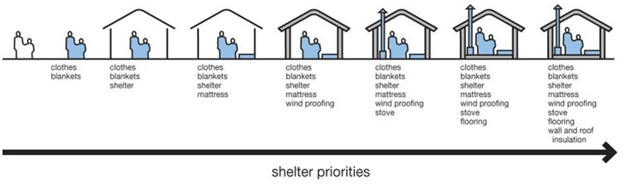

**Winters-2023/24 Visualized contingency Scenarios.**

Visualized contingency scenarios derived from PMD’s (Pakistan Meteorological Department) Outlook for Monsoon-2022/23 are as under.

**Scenario-1 (Most Likely) - Normal to Below Normal**

* Less rainfall / snow in northern parts of country; Khyber Pakhtunkhwa, Gilgit Baltistan, Punjab (Murree) and AJ&K.
* Nearly Normal / beneficial rainfall in respective southern parts of the country; Southern Punjab and Sindh, whereas Balochistan to have nearly normal rainfall and snowfall in higher altitudes / mountainous areas.
* Temperatures decline on a steady scale during winters.
* Development of fog / mist in low-lying / plain areas of the country.
* Dust-raising windstorms are likely/ expected in Southern Punjab and Northern Sindh.
* Extreme winter events (blizzards, cold waves, ice-storms, hailstorms) considered less-likely, however, cannot be ruled out entirely.
* Expectation of temperatures remaining “above normal” in northern parts of the country may lead to avalanches in vulnerable areas where snow on slopes may have weakened / destabilized.
* There is a likelihood of flash flooding in parts of Balochistan, where soil is already saturated and many check dams were damaged.
* Cold and relatively dry weather conditions will exasperate the smog conditions, further reducing the air quality index of affected areas.

**Scenario- 2 (Likely) - Normal**

* Normal rainfall / snow in northern parts of the country; Khyber Pakhtunkhwa, Gilgit Baltistan, Punjab (Murree) and AJ&K.
* Nearly Normal / beneficial rainfall in respective southern parts of the country; Southern Punjab and Sindh, whereas Balochistan to have nearly normal rainfall and snowfall in higher altitudes / mountainous areas.
* Temperatures remain close to average temperatures during the winter season.
* Development of fog / mist in low-lying / plain areas of the country to be prevalent during earlier part of the season.
* Dust-raising windstorms with less intensity likely in Southern Punjab and Northern Sindh.
* Dry-cold weather conditions will exasperate the smog situation in Punjab, further reducing the air quality index of affected areas.
* Potential cold waves to exasperate winter situation nationwide causing rapid decrease in temperatures and increasing strain on heating fuel for homes.
* There is a likelihood of flash flooding in parts of Balochistan, where soil is already saturated and many check dams were damaged.
* Wet spells in colder temperatures may lead to freezing rains / ice-storms in upper parts of the country which may jeopardize above-ground electrical lines due to icing. Furthermore, roads may experience forming “black ice” making driving conditions hazardous / slippery.

**Scenario-3 (Less Likely)** **- Above Normal**

* Above Normal rainfall / snowfall in northern parts of the country; Khyber Pakhtunkhwa, Gilgit Baltistan, Punjab (Murree) and AJ&K.
* Normal rainfall in respective southern parts of the country; Southern Punjab and Sindh, whereas Balochistan to have nearly normal rainfall and snowfall in higher altitudes / mountainous areas.
* Temperatures will decline at an increased pace during winter season.
* Development of fog / mist in low-lying / plain areas of the country will be experienced during the earlier part of the season.
* Dust-raising windstorms will be less likely Southern Punjab and Northern Sindh.
* There is a likelihood of flash flooding in parts of Balochistan, where soil is already saturated and many check dams were damaged.
* Potential cold waves to exasperate winter situation nationwide causing rapid decrease in temperatures and increasing strain on heating fuel for homes.
* Wet spells in colder temperatures may lead to freezing rains /ice-storms or hailstorms in upper parts of the country which may jeopardies above-ground electrical lines due to icing. Furthermore, roads may experience forming “black ice” making driving conditions hazardous / slippery.
* Heavy snowfall in northern parts of the country; Khyber Pakhtunkhwa, Gilgit Baltistan, Murree Region, higher altitude / mountainous areas of Balochistan and AJ&K, which may cause road closures and possible damage to communication infrastructure (roads and telecom)

**Winters-2023/24- Shelter NFI CCCM Sector Preparedness**

Shelter NFI CCCM Sector timely initiated winter 2023/24 preparedness in last week of September 2023, considering the start of winter season in North KP, Balochistan and GB. The following measures have been taken by the sector so far.

* **Winter strategy**

Draft winter strategy at National level prepared, and upon approval will be presented at ISWG meeting, and HCT Meeting. It will also be shared with the key stakeholders including partners, Government, N/PDMAs.

* **Winter stocks mapping**

[Winter_Contingency_Stock_Mapping_09Oct23.xlsx](https://iomint-my.sharepoint.com/:x:/g/personal/muhammadkhan_iom_int/EYar4IuPzt5OpsnKsoMFYaABKTL8N9PFQ0cdgkl_fpr30w?email=ssraza%40iom.int&e=Z336yp) has been completed and the summary is given below.

|  |  |  |  |
| --- | --- | --- | --- |
| **Potential Coverage** | | | |
| **Items** | **Stock** | **HHs** | **Individuals** |
| **Blanket** | 29,860 | 4,266 | 29,860 |
| **Quilts** | 7,496 | 1,071 | 7,496 |
| **Warm Cloth** | 21,650 | 3,093 | 21,650 |
| **Winterization Kit** | 97,705 | 97,705 | 683,935 |
| **Stoves** | 9,500 | 9,500 | 66,500 |
| **Total** | **166,211** | **115,634** | **809,441** |

**Annex A: SHELTER Sector RECOMMENDED NFI KIT FOR FLOODS RESPONSE**

The underlined items provide winterized support.

|  |  |  |
| --- | --- | --- |
| **NFI KITS** – suggested  Jerry cans/ hygiene kits/ mosquito nets etc. are not included as they are covered by the WASH and Health Clusters | | |
| High priority | Blankets* | 4 single or 2 double (Northern areas) |
| 3 single (Southern areas) |
| Warm shawls | 2 adult, 4 children |
| cotton mattress | 1 |
| Sleeping mat | 1 |
| Lower priority | Fuel efficient cooking stove** (with access to appropriate  fuel) | 1 |
| Clothes*** (fabric and sewing kit preferable to clothes) | 1 |
| Floor sheets or ground mats | 1 |

* Fewer blankets are required in southern areas.

** In previous emergencies in Pakistan, fire outbreaks in tents and temporary settlements have led to the banning of stove distribution. All stoves and lamp distribution programs should be accompanied by fire safety public information and preparedness.

***In the immediate aftermath of the flooding, clothes are a significant need. However, to reach coverage of the largest number of families there will be delays in distribution.

Suggested clothing package:

* Winter Jacket Adult (M or L)- 3 units
* Winter Jacket Children (children M)- 4 units
* Winter undergarments for Children (children M)-4 sets
* Socks Adults- 6 pairs
* Socks for Children (children S-M) 8 pairs
* Warm Cap Adults- 2 units
* Warm Cap Children (children S-M)- 4 units
* Ladies winter shawl- 2 units

Technical ⃒**2010**

# 

# **Annex B: 2023** Winterized Shelter Technical Guidelines

## **→** Winterized Tent

A winterized tent must be made of waterproof canvas and must have a strong supporting frame. It must provide a minimum of 12m2 (130sq.ft.) covered area. Additionally, a winterized tent has the following components:

### Fly sheet

Separate fly sheet, usually made from canvas, which fits over the inner tent.

### Flue manifold:

The inner tent and flysheet each have a metal plate with a hole in it. These plates are sewn in or fixed into a canvas pocket. This allows for a stove with a chimney to be placed inside the tent without the risk of the flue pipe igniting the canvas when hot.

### Structural supports:

The poles which form the vertical supports, and the ridge beam should be made of a thick gauge steel (min 1.5mm) and with an external diameter of 35-50mm. This gives suitable structural resistance to both high winds and snow loading.

### Inner lining:

The inner tent may have a light cotton (‘desouti’) lining.

### Mud flaps / valences:

The tent must have rot proof mud flaps of suitable quality and length to allow the tent to be dug into the ground.

The following graphic illustrate1 and example of how plastic sheeting, rope and sand bags may be used to winterize a tent:

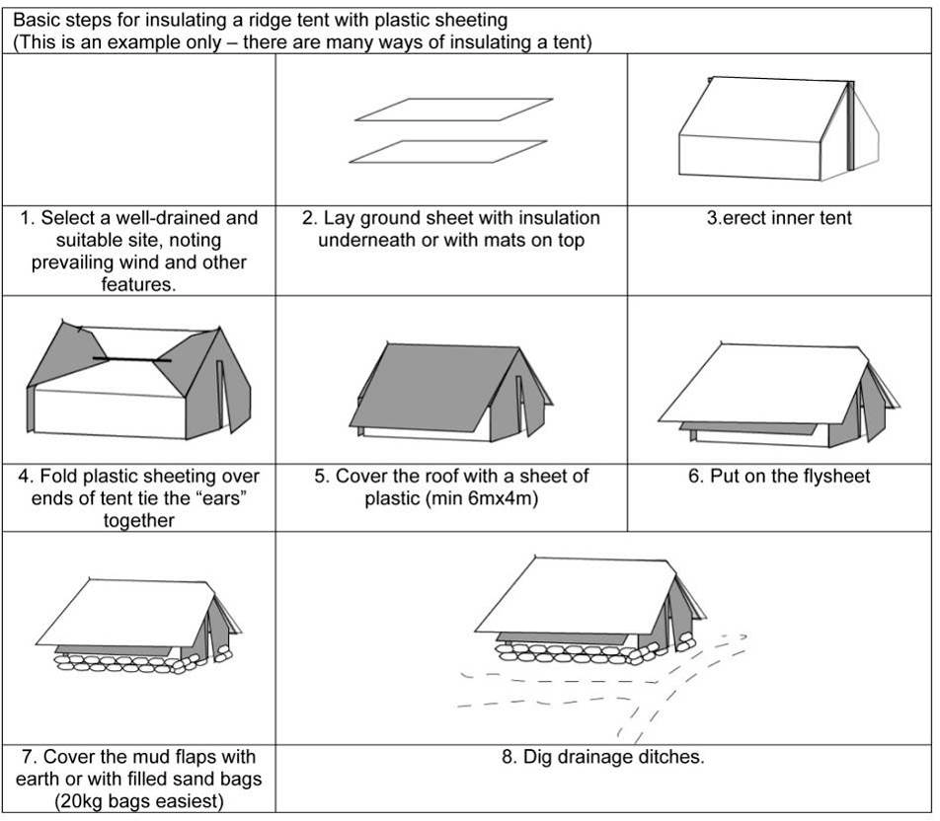

## 

## **→** Winter Adaptation of Tents by Beneficiary

Beneficiaries can upgrade tents in many ways. Sensible adaptations should be encouraged. Observed strategies adopted by beneficiaries from previous response include:

* Raising floors with timber or stone to reduce draughts and increase insulation.
* Digging in of valences /mud flaps to reduce drafts and risk of flooding.
* Construction of low walls, potentially head height walls to increase thermal mass and reduce drafts.
* Use of plastic sheeting or blankets over closed ends of tent to reduce drafts.
* Use of stoves for cooking and heating at key times of the day when cold is most intense.
* Excavating the interior space of tents to reduce ground level drafts where there is adequate drainage.

## Kit for Winterization

## Upgrading of Tents

The basic materials required to winterize a tent are plastic sheeting and rope with blankets and floor insulation for personal shelter. Below are the priority items that a family will need to provide for tent winterization. The remaining materials to be distributed will depend on what families have already possess2:

* Minimum 2 high quality wool blankets **per family** (minimum TOG value of 2.0). If high quality synthetic blankets (generally brightly patterned fleece type material) or thick quilts are used, fewer than 2 may be

used. Mattresses are the preferred form of ground insulation but are subject to logistics constraints.

**sphere NFI standard 1 guidance note 3:** “*Provision of insulated sleeping mats to combat heat loss through*

*the ground may be more effective than providing additional blankets”*

** plastic sheeting - (OXFAM/MSF quality preferred, reinforced with bands) to wrap the tent and cover

the floor. This corresponds to two or three 6mx4m plastic sheets.

*** clothes **must be winter clothes**, clean, compressed, sorted by age/size and gender and culturally appropriate.

**sphere NFI standard 1 guidance note 3:** “*Changes of clothing: individuals should have access to*

*sufficient changes of clothing to ensure their thermal comfort, dignity and safety. This could entail the*

*provision of more than one set of essential items, particularly underclothes, to enable laundering*”

**** general ground insulation reduces ground heat losses. Partially flooring a room with blankets and plastic sheeting will allow people to sit reducing direct conductive heat loss.

Note that sandbags may also be used

in the construction of basic walls.

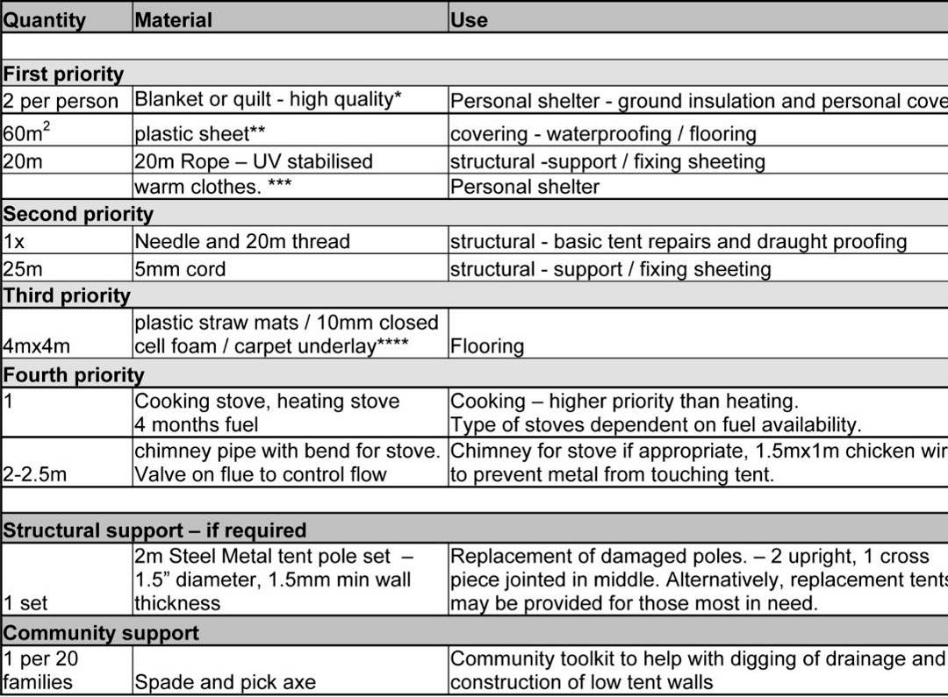

# Fire Safety recommendations for temporary settlements

Source: Shelter Cluster Pakistan - Dec’05-Jan 06

